Outcome Guide
for
Georgia’s Crime Victim Assistance Programs

Prepared for:
Georgia Criminal Justice Coordinating Council
104 Marietta Street, NW
Suite 440
Atlanta, Georgia 30303-2743
http://cjcc.ga.gov

Prepared by:
Performance Vistas, Inc.
2145 Azalea Drive
Roswell, Georgia 30075
www.PerformanceVistas.org



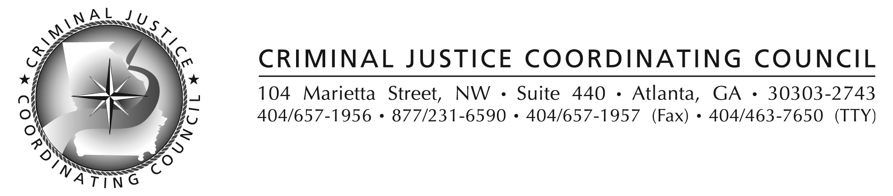
Performance Vistas, Inc.
O: (770) 992-0679 F: (770) 992-8394

Table of Contents
Chapter One: Your Program’s Design  Why Measure a Program’s Performance?................................................................  The Basics of Program Logic Models……………………………………………..  The Importance of Purpose for Program Design………………………………......  Program Inputs: Defining Assumptions about Needed Resources………………..  Program Activities: Expressing the Logic of your Program Interventions ……….  Performance Measures: Outputs, Satisfaction and Outcomes…………………......  Performance Data Collection Strategy: Priorities, Methods, Tools………………  Chapter Two: Implementing an Outcome Data Strategy  Outcome Data: Which programs must measure? Which surveys to use?.....………  Outcome Data: Which measures? Which clients? “substantial completion”...…….  Outcome Data Aggregation (using CJCC’s Excel Spreadsheets)……..…………...  Outcome Data Reporting (using Online Reporting Screens)……………...……….  Appendices:  A. Worksheet and Guidelines for Preparing your Program’s Logic Model  B. Sample Outcome Survey Instruments  C. Tips for Developing Survey Instruments  D. Guidelines for Outcome Data Collection  E. Glossary of Terms  F. Links and References | Page #  1  1  3  5  6  7  8  9  12  12  13  19  25  30  31  32  41  48  51

Chapter One: Your Program’s Design

Why Measure a Program’s Performance?
Most crime victim assistance leaders acknowledge that our programs have a responsibility to impact our clients in positive ways. Most of us also believe that it matters how well we adhere to standards of practice as we go about our work serving our clients. These are the reasons most of us enter the field: We forego the promise of larger corporate salaries because we care more about helping vulnerable people. If you agree, then you probably also believe that determining how well our programs are performing is at least as important as documenting how hard our programs are working.

You might even say our motto should be “Results are as important as Effort.” That stance shifts our emphasis from counting program activities to include as equally important the results of those activities on the lives of our clients. Caring about changing lives doesn’t mean we can forget about reporting the volume of our program activities, and it doesn’t replace the need for attending to high quality (or even “best”) practices. It just means we don’t stop there – we must inquire into our clients’ lives and discover whether (and how) they are improving.

What do we mean by “results” in crime victim assistance? The desired results of our programs are defined as client or victim outcomes. What are client outcomes? Outcomes show what difference a client’s involvement with our programs made in his or her Knowledge, Skills, Attitudes, Behaviors or Conditions (what we call “KSABCs”). Did she learn more about her rights? Develop some parenting skill? Change her view on deserving physical punishment? Find a way to avoid risky circumstances? Actually reduce her risk level or improve her health? Those are all changes that are partly the results of effective programs.

Here are eight more reasons it’s important that our programs pay attention to how we affect victims of crime (i.e., help them achieve desirable family outcomes):
- Helping our clients recover and find better lives is the major reason we exist.
- Tending to how clients’ lives are changing helps us stay focused on our mission.
- Thinking in terms of changed lives provides us with a common language. We will disagree on the best ways to help, but we can agree on what a changed life looks like.
- Our programs must demonstrate we are responsible stewards of public and private financial support. We must be accountable for our decisions.
- Our funders want to know not just how hard we are working for their money; they need to know we are making a difference in peoples’ lives.
- Knowing how lives are changing gives us meaningful facts to tell our stories.
- In a tight economy having credible information about how lives are changing gives those who have it a competitive edge over those who do not.
- All our stakeholders must be able to make decisions about their support in “up” as well as “down” times. Information on how clients’ lives are changing is crucial information on which to base hard choices.

Measuring Client Outcomes: It’s No Longer “Business as Usual” People with a “stake” in the success of crime victim assistance (our stakeholders) might include the public, our clients and their children, our agencies’ community partners, our staffs, and our funders. Our stakeholders haven’t always paid attention to the “bang they get for their bucks” as closely as they do now. But right now, the financial times have stakeholders everywhere focusing closely on whether their investments are providing justifiable returns. The trend in recent years has been for victim assistance programs to:
- Concentrate on using grant money to achieve the purposes spelled out in the grants.
- Let go of their sense of entitlement to grant money. A history of previous awards can no longer be a predictor of future awards. The State of Georgia has to produce performance data to compete for its awards, and so eventually will its sub-grantees.
- That means that a program’s application for VOCA, VAWA or SASP grants in Georgia will require logical project narratives that will show how the program intends to achieve the purposes of the grant, as well as to comply with grant requirements.
- The Georgia Criminal Justice Coordinating Council (CJCC) is trying to help its partners, like you, anticipate and deal with these challenges. That is the reason for this Guide.

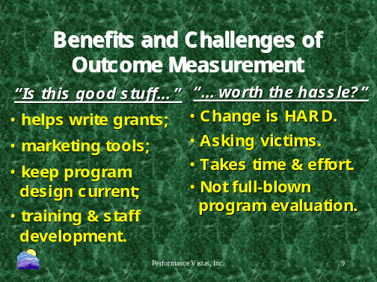This movement toward measuring performance, especially outcomes, is a big change. And change isn’t easy. So, it comes down to a major question: “Are the hassles worth the benefits?”
CJCC believes the following positives outweigh the negatives of measuring program performance:
- Measurement leads to better programs, and to a better understanding of how good programs are designed and operated, so others can replicate them.
- Measurement helps program administrators keep their programs focused on client outcomes, which helps in grant-writing and marketing their programs.
- Using results data to manage a sub-grant helps you and your staff avoid mission creep (purpose drift) by forcing you to think through and share the program’s assumptions about what needs to change, and what kinds of activity make those changes happen.
- It helps you link your program’s activities with the kinds of outcomes you expect victims to accomplish as they work with you.
- Discovering what actually happens can help programs make internal improvements.
- Outcome data are also very useful at the state level, in program planning and evaluation – which are both essential for the continuation of the crime victim services programs.
- The process makes it possible for state program managers to provide better monitoring and technical assistance in support of sub-grantee programs.
By addressing similar measures, CJCC’s program measurement process supports collaboration and benchmarking (shared data on what works), which helps build partnerships.

But few programs have long histories of performance measurement. Measuring a program can be HARD! It is…
- Hard to let go of counting effort as our main measurement approach. We are used to counting how many clients we serve, how many crisis calls we take, how many hours of counseling we provide – and that’s the only performance data most of us have ever been asked to produce.
- Challenging to just accept these changes without feeling that the outcomes data will be misused. How do we know it won’t just be masking an effort to put us out of business? Past experiences with trust issues can undermine even the best initiatives.
- Difficult to wrap one’s brain about all this new terminology. The concepts are foreign. It seems like a lot more work when time is really short now already.
- It is not what classical researchers would consider full-blown program evaluation.
Actually, if these changes were easy they would already have been made!

The Basics of Program Logic Models
What is a logic model? How does a logic model help a program move toward measuring outcomes? We will examine the definitions you will use for developing a program logic model for a grant application, for a public relations or marketing plan, or for a training package for new employees. Logic models are useful for other valuable management applications, too.

What is a Logic Model? It is a…
- A disciplined way of mapping inter-related components of your program.
- A chart that links the key stages in your chain of reasoning for what works to affect changes in the lives of crime victims.
- A platform for discussing how you intend to implement and evaluate your program.
- Multi-purpose tool useful for many different management activities (i.e., it is not one-dimensional, as in “just to keep the state off my back”).
- “Means” to the “end” of safer, more knowledgeable, better equipped and more powerful clients – and not an “end” in and of itself.
- Not “fixed” forever in time – a one-time “use-it-and-forget-it” tool – but a flexible tool that keeps on giving returns on the investment, if you use it wisely.

A logic model is a logical description of how your program is supposed to operate in order to produce the results you are in business to accomplish. A high quality logic model makes it possible for anyone – clients, staff, board members, community partners and stakeholders – to understand the assumptions underlying your program’s design. There are no exact “right” or “wrong” ways of producing a good logic model. Some good logic models have been developed that are merely graphic explanations or charts: A series of IF-THEN statements that flow in boxes from one assumption to another, like the one below, designed to spell out the assumptions underlying the practice of taking an aspirin to feel better.

If my… …then I… …and I should… …but what really happens?
head aches
take aspirin
feel better
I DO feel better!

Problem Activity Intended Result Actual Result
We assume the aspirin will reduce the headache, but we have to check later to determine whether it actually happened! If we find that the intended result did not actually happen, it might be time to change the treatment or get a medical opinion, because the treatment (our aspirin) did not accomplish what we thought it would. Better to know this in time to get a second opinion than to wake up in the emergency room with an aneurism!

What is a logic model used for? It defines your rationale, your underlying assumptions about what works to help change the lives of your clients (i.e., the victims and survivors of crime). It lays out your program’s DESIGN ASSUMPTIONS to explain why you do what you do in your program. It helps you focus on which people you will target your services (e.g., children or vulnerable adults?) and which of their problems are yours to address (domestic violence or child abuse? mental illness or financial recovery? emergency housing or court accompaniment?). It explains what you expect to happen when you answer the phone, open the doors, provide crisis support, advise on rights, help a client find resources, navigate a complicated and challenging criminal justice system. It also gives you what you need to recognize when you have succeeded, and for which clients your assumptions have gone astray. Your program needs a logic model to define who it is, identify what makes it unique, and concentrate its limited resources where they count the most. And to recognize when it does well, when it does not do so well, and what to do about it in either case.

Logic models that specify program designs sometimes go beyond simple graphics to include “word pictures” of what the program “looks like.” These narrative depictions of your design can be used for training your staff, orienting your clients, aligning your community partners, educating your potential funders, and managing your program both daily and strategically. The most common form of narrative logic model is the kind required by funders, such as United Way or the Georgia Criminal Justice Coordinating Council, as the narrative justification supporting your agency’s grant applications.

The Logic Model approach adopted by the Georgia Criminal Justice Coordinating Council is based on one developed by Performance Vistas from 1998 until 2006, and modified slightly to accommodate the one developed by the University of Wisconsin Extension Service. CJCC uses several concepts to spell out the important segments of a good logic model. Below are definitions of the major concepts. After that there are some more detailed explanations of these five important terms.

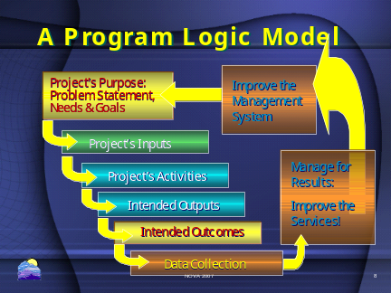Purposes identify the magnitude of the sort of problems faced by the community being addressed by the funder. Purpose geographically and demographically pinpoints the targeted victims, explains those victims’ needs to be met by the program, and spells out the goals of the program (its intended results). Purpose lays out the reason for the program’s existence.

Inputs are the resources a program will consume to produce the program’s activities. Common examples include money, staff and staff time, volunteers and volunteer time, facilities, equipment, and supplies. Case referrals and training for program personnel are two other, more subtle forms of inputs. Inputs are the resources used by a program to perform its activities and deliver its outputs and outcomes. They are the logical explanation for a program budget.

Activities are what a project does with the inputs to fulfill its mission. Activities include the strategies, techniques, and types of intervention that comprise a program's service methodology. Crisis call support, advocacy, court accompaniment, counseling, support groups, education, prevention, financial assistance, transitional housing and specialized care are all program activities. Activities are those actions that move a program toward the program’s goals and its clients toward their outcomes.

Performance Measures: The approach CJCC uses calls for three types of performance measure:
- Outputs are counts of the direct products of program activities. They usually describe the volume of work accomplished, such as the number of classes taught, counseling sessions held, people served, public education billboards erected, or orders of protection obtained from the court. They often are also counts of people served in certain categories, like age, race, gender, income, etc. Outputs represent the efforts of the program – how hard it is working for its clients and stakeholders.
- Satisfaction measures are client statements rating the quality with which the services were provided. Usually these measures address how accessible the services were (such as how hard it was to find the agency or the time spent waiting for an interview). Some satisfaction measures deal with how acceptable the services were (such as whether the client was welcomed and treated with respect). Others address how well the services matched up with generally accepted standards for the service (such as numbers of people in a support group or frequency of court hearings the client was accompanied by staff of the program). Satisfaction measures are not the same as either outputs or outcomes, although they are often confused with them. Satisfaction measures represent the quality of the service activities, focused on program behavior
- Outcomes are benefits resulting from the program’s activities. For a legal advocate these changes might be increased knowledge of rights or awareness of alternatives. For a crisis intervention (e.g., domestic violence or sexual assault program), it might be some degree of physical recovery or emotional stabilization, or a change in a client's behavior or condition. For a children’s advocate, an outcome might be another step toward permanency. Outcomes show what difference a client’s involvement made in his or her knowledge, skills, attitudes, behaviors or condition (KSABCs). Outcomes express the extent to which a program’s clients accomplished their goals and achieved the changes they wanted in their lives. Focusing on clients’ lives helps define whether a program met its stated purpose of changing lives.

Data Collection Strategy provides the explanation of how output, satisfaction and outcome data will be gathered, summarized, and reported. A program’s logic model should explain the reasoning for using client exit interviews or written surveys to obtain client feedback on outcomes and outputs, as well as client satisfaction with the service experience. It should also explain and provide examples of the tools to be used for gathering the information. It should lay out the process to be used for data collection (e.g., the point or points in the service process when data will be collected, who is responsible for collecting the data, protocols for storing the tools, data aggregation processes and responsibilities, data analysis procedures and responsibilities, and reporting logistics). Data Strategies describe how the program’s measurement activities will take place.

1. The Importance of Purpose in Good Program Design
Purpose is to a good logic model what a GPS destination is to travel. Your program’s purpose statement should clarify its intended results. It should define how you will recognize it when you succeed. Purpose defines what the intended outcomes should be, by clarifying who you are serving, what problems they have that you can address with the funder’s resources, and what the target population needs that you can provide. It should have three design elements:
a. Problem Statement: Your problem statement should be stated in terms of people in the community, clients or constituents, rather than the needs or problems of your organization. It should also be supported by evidence drawn from your experience, from statistics provided by authoritative sources and/or from the testimony of persons and organizations known to be knowledgeable about the situation. Answer these questions:
- What social problem are you tackling that is consistent with the funding you are applying to use? Is it poverty and poor housing? Or is it child abuse? Domestic violence? Sexual assault? Violent crime? Driving under the Influence? Homicide? Combinations of these things?
- How big of a problem is it? What is its magnitude and what are the trends? How many are affected? How many are affected given the general population (i.e., per capita)? Is it getting worse? What are your sources for these arguments?
b. Needs of the Target Population: Your needs statement should identify as specifically as possible the target population for your program (not necessarily your entire agency). Since you will be unable to serve everyone with this problem under this program, which ones will you serve? Define your program’s scope geographically (e.g., by neighborhood, county or judicial circuit) and demographically (e.g., by age, race, economic level, gender, etc.). Answer these questions:
- Which elements of the general population are to be served as targets of this program? How will you address people who are traditionally underserved in the area?
- What are the demographic characteristics of this target population?
- What geographic area will be served? Where may the target population be found, and will the program merely be based in an area, or will it reach out to serve all targeted people within the area?
c. Goals of your Program: If you wish to pursue funding from a specific funder, it makes little sense to address a purpose or goals not considered important or even supported at all by the funding source you are pursuing. You have to know what the funding program requires when serving targeted people. You must also know what the funding program will NOT support. Answer these questions:
- How does the proposed program clearly relate to the purposes and goals of the funding source?
- How does the proposed program “fit” with the mission, values and goals of other agency programs, and by extension with the strategic direction of your organization?
- How has your design been kept within reasonable dimensions? Describe how this social problem can realistically be improved upon over the course of the grant.

2. “Inputs” Define Assumptions about Needed Resources
Inputs are the resources invested in the program to produce the activities, which in turn produce the results. Inputs are generally considered to be the direct budgetary requirements of the program. They may be explained in detail under headings for:
- Personnel (e.g., salaries, fringe benefits);
- Operating expenses.
Answer these types of questions about the assumptions underlying the proposed budget, often following the outline of an itemized budget:
- How many positions will this award support? How many full time, and how many part time (and what percentage of their time)?
- How many positions at what experience levels, with what educational levels, and what skills sets?
- What assumptions are you making about the cost of these personnel (hourly rates, salaries, cost of fringe benefits, etc.) and why are these called for by the design?
- What operating costs are to be assumed by the funding source (e.g., rent, equipment, utilities, etc), and why are these called for by the design?
- If your approach requires allocating costs to various funding sources, what assumptions are being made about each source’s contributions?
Quite often the “inputs” section of a program logic model also are discussed as non-budgetary resource requirements, such as these examples:
- Training for program staff: What kinds of training for which types of staff will be required?
- Service systems, such as case management systems: What types of software and hardware are required to meet grant expectations?
- Overhead or administrative costs of keeping the program in operation. What kinds of expenses are expected to be incurred as the “costs of being in business?”
- Collaborative agreements with partner agencies: What partners are required by the program design, and what kinds of activities must be supported to ensure these collaborative relationships?

3. Program Activities: Expressing the Logic of a Program’s Interventions
As defined in the VOCA Program Guidance, funded
“services are defined as those efforts that (1) respond to the emotional and physical needs of crime victims; (2) assist primary and secondary victims of crime to stabilize their lives after a victimization; (3) assist victims to understand and participate in the criminal justice system; and (4) provide victims of crime with a measure of safety and security such as boarding-up broken windows and replacing or repairing locks.”

Typical services include crisis intervention, advocacy, accompaniment, support and related assistance for adults, youths, and child victims of sexual assault, family violence, and other crimes. Often the services focus on the family members or survivors of the primary victim of the crime, who are collaterally affected by the crime. Interventions may include 24-hour hotlines for information and referral, or for crisis stabilization. Advocacy often involves engaging professionals on behalf of the victim, such as with the courts, medical, law enforcement, and social support systems – and may include service coordination and case supervision in collaboration with other providers of service to the victim. Accompaniment services often address the same systems as advocacy services, and may include help with language and cultural factors. Support can be crisis intervention for the short term on an individual or group basis.

All these types of services exist as the means of achieving those results the program was designed to create: emotionally recovering victims, victims whose lives are stabilizing, victim who understand how to participate with the justice system, and victims who experience improved safety and security. These services are reimbursed under the VOCA and VAWA programs because they help change victims’ lives – not simply to keep agencies in operation.

One thing all authorized services have in common in their ability to be counted. Programs are required to count their activities in order to demonstrate how hard they are working for the resources provided by a funding program like VOCA or VAWA. CJCC accounts for activities by counting both:
- the units of service (e.g., numbers of crisis calls, hours of court accompaniment, and
- the number of victims served (e.g., numbers participating in groups, numbers of children accompanied to court, etc.)
CJCC requires grant sub-recipients to report the volume of their funded activities quarterly, using forms required by the Justice Department. Programs like yours should refer to those requirements. Chapter Two provides more on the details of collecting and reporting activity.

4. Performance Measures: Outputs, Satisfaction and Outcomes
OUTPUTS are counts of activity, usually expressed as numbers of clients served in a given period (# intakes/year), or the number of hours of service (# hours in court on client matters), or the numbers of services quantified (e.g., number of counseling sessions). Output measures are often the easiest to obtain data on. They answer the question: “What & how much are we doing?” Most program managers are accustomed to reporting outputs, as these measures have been used for decades as evidence for how much a program produces.

SATISFACTION measures are summaries of what the clients (“customers”) have had to say about their experiences with the program. Satisfaction measures comment upon the quality of a program’s efforts, such as the timeliness or friendliness of staff. Satisfaction data should not be confused with a client’s self-report on outcomes. Satisfaction measures are more difficult to obtain data on, and may be most subject to bias introduced by the method of data collection. For example, asking a client in person to comment on the quality of service we have provided might not get an honest answer – and therefore must be handled carefully. Satisfaction measures answer the question: “How well are we providing services?” Many programs have used this type of measurement with little appreciation of how client feedback can be influenced by the approach used to gather it – making much of it meaningless.

OUTCOMES measures are counts of results. These are changes in clients’ lives. They are often confused with statements about the satisfactory nature of the service. Instead, they summarize the number (or percentage) of clients who indicate that they recognize certain changes in their lives. These changes will, in well designed programs, mirror the purpose of the program, which ties back to the needs of the people targeted by the program, and the purpose of the funding. Outcome measures answer the question: “How is the victim doing?”

Examples of Output Measures used as Program Metrics by VOCA, VAWA, SASP programs:
- Federal & State Required Reports by Fund Source (VOCA, VAWA, SASP)
    - Number of Victims Served by Type
    - Number of Services Provided by Type
    - Demographics of Victims Served
    - Examples of data needed to be collected and reported to CJCC by grantees:
    - # receiving transitional housing
    - # crisis calls
    - # emergency meals
    - # cell phones distributed
    - # support groups convened
    - # educated about rights and alternatives
    - # victims counseled, by ethnicity
    - # child victims accompanied to court

Examples of Satisfaction Measures used as Indicators of Program Quality:
- State Required Reports (VOCA, VAWA, SASP)
- How easy was it to locate and access services?
- How well were you treated by program staff?
- How timely was the service you received?
- How close was the service to its published promises or commitments?
- Example, taken from CJCC required measures: “I am satisfied with the services I received from [your agency name here]”

Examples of Outcome Measures used as Indicators of Program Results:
- State Required Reports (VOCA, VAWA, SASP):
- Number of victims reporting agreement with certain statements selected for their relevance to the program’s design.
- Different measures for eight different types of VOCA and VAWA programs (DV programs, SA programs, CASA programs, Child Advocacy programs, legal services, victim-witness assistance, and counseling programs for children and families).
- Examples:
    - Physical and Emotional Needs Met: “My family has a better understanding of child abuse/violent death and its effects on victims and their families/surviving family members.”
    - Symptoms Reduced: “My child’s abuse/loss-related symptoms, such as sleeplessness, nervousness, fear, anxiety or acting out are less severe since our involvement with this agency.”
    - Resolution of a crisis: “I am better able to cope with my situation.”
    - Understanding/Participating in the Criminal Justice System: “My family has a better understanding of the legal rights of a victim of child abuse/survivor of crime; I now have a better understanding of how the police, lawyers and courts work.”
    - Sense of safety & immediate security: “I know how to create and adapt a safety plan; I feel safer.”
    - Reduced isolation: “My family has learned how to contact the sources of help available to us in the community.”
    - Life choices made: “My family is using the skills we learned to cope with our situation.”
    - Improved understanding: “My child understands that changes in our family following the abuse/death are not his/her fault.”

5. Performance Data Collection Strategy: Priorities, Methods, Tools
What follows is a step-by-step approach for developing your agency’s data collection and reporting strategy. Start by developing your logic model (as outlined above). There is a worksheet and guidance for preparing a logic model in Appendix A.
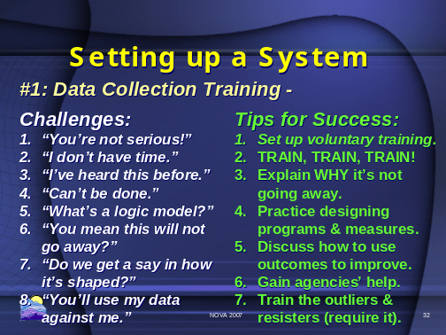5.1. Train your staff for performance measurement.
- Start with a basic understanding of the reasons for performance measurement.
- Explain the main elements of logic models.
- Get them involved with developing the logic model for their program(s).
- Explain your strategy for data collection, analysis, and reporting. Provide examples!

5.2. Study the Guidelines for Data Collection
- 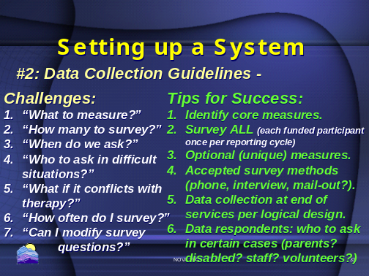Nothing changes about the way your program gathers and reports its output data. Keep doing what you have been doing for counting activities and clients. Chapter Two highlights the process CJCC requires of its VOCA, VAWA and SASP sub-grantees.
- Examine closely the VOCA, VAWA & SASP core outcome measures. See Appendix B for samples.
- Identify additional measures your program needs for measuring its own outcomes.
- Decide when (at program completion), how, (by client written surveys) and by whom the data will be collected (staff, with certain parameters).
- Make sure you are in compliance with CJCC requirements! Chapter Two details CJCC’s requirements for measuring outcomes.

5.3. Try collecting the data, summing it up and interpreting it.
- 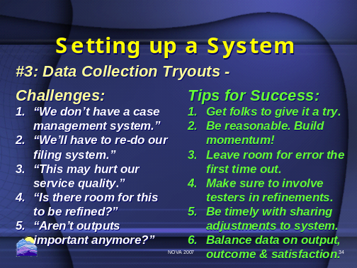Take some time to build up processes. Be patient.
- Learn from mistakes.
- Adjust! No system will be perfect the first time out.
- Do not overlook one form of measure in favor of the others. Satisfaction data are important, but no more so than outputs and outcomes.

5.4. Get help from CJCC.
- 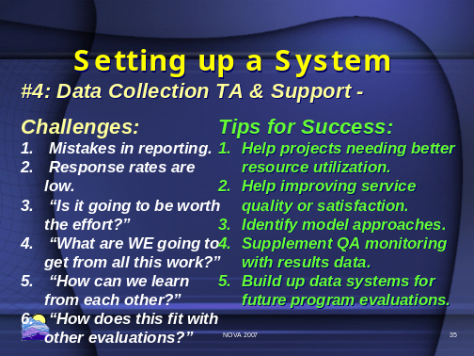Ask for help from those with experience.
- Integrate what you learn from measurement with what you usually learn from quality assurance and program reviews.
- Focus on getting better and more trustworthy data as your staff gets more comfortable with collecting the data.

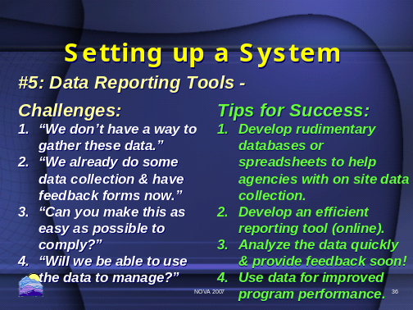 5.5. Use the tools provided for by CJCC!
See Chapter Two for specific guidance on data collection, aggregation and reporting for OUTCOMES.

Chapter Two: Implementing an Outcome Data Strategy

Which Victim Services Programs Must Measure Client Outcomes in Georgia?
CJCC’s requirement applies to VOCA, VAWA and SASP sub-grantees that deliver direct services to clients who are victims of crime, and whose contact with clients is more extensive than a single telephone call or other distribution of information (hotlines). Primarily, this will include sexual assault programs, domestic and family violence programs, child advocacy and CASA programs, counseling and treatment programs, legal services, and various forms of victim assistance whether based in law enforcement, prosecution or other settings. Training projects and special projects such as fatality reviews, coalitions, and investigative units will not be measuring outcomes until notified by CJCC staff. CJCC will work with these special sub-grantee programs to identify outcome performance measures for these types of projects at a later date.

Agencies with Activities Partially Funded: Agencies that receive funding from CJCC for a separately staffed, self-contained program, and in which those clients do not receive any other victims’ services from the agency or from any other staff, may choose to collect outcome data only on those clients. Agencies are encouraged, however, to collect outcome data on all clients if they choose and report them to CJCC.

Single positions funded by CJCC: Agencies that receive funding from CJCC that supports one staff member out of several, and in which clients may receive services from all staff at any particular time, must collect data from all clients served. First, the outcome of your program on clients is produced by the cumulative effect of all services received and all contacts experienced, and it is impossible methodologically to separate out the impact of one staff person from among the many. Second, even if each staff member sees her or his own group of clients, it creates an extra burden for that staff member and may give that staff member’s clients the impression that they are being singled out for some reason. Third, the agency misses out on the opportunity to learn what impact the program is having on all its clients.
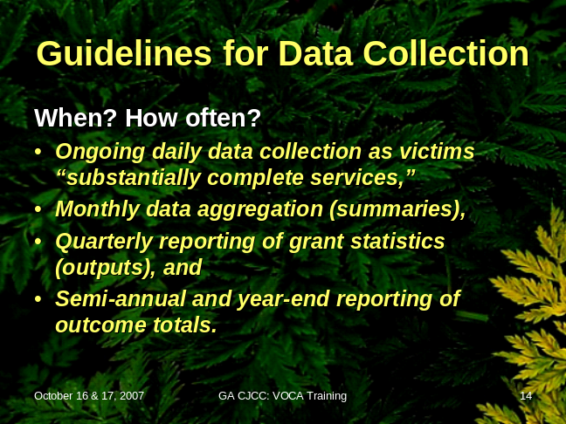
Your strategy for measuring outcomes will require someone to collect outcome responses daily from clients as people complete their services. Someone within your program will have to aggregate these responses at least monthly. Someone will have to log onto the internet reporting site twice each year to submit your agency’s outcome data. Clearly, someone will have to be in charge of these details – someone who is comfortable with keeping tabs on the survey forms, making sure everyone with responsibility for gathering data is doing what they committed to do.

So, who will manage data collection and reporting in your agency? Who will be accountable for accuracy? CJCC suggests that the Executive Director or other appointing authority in your program should manage the measurement process. Ultimately, the information your program gathers should benefit your program’s leadership more than anyone else, and for that reason alone the integrity of the process ought to be managed carefully.
Your Strategy for Measuring Outcomes Data Will Address Four Questions:
- Which outcome measures apply for your particular program, and what instruments will you use for collecting the information on those outcomes?
- Who will provide the data you need, and at what points in the process will you collect data?
- Who will actually gather the data, and under what circumstances?
- Who will aggregate the data, analyze it and report it – and how?

How you answer these questions should be guided by your program’s design (i.e., its logic model). You will have to explain these design assumptions when you report your outcome data, so let’s take these questions one at a time!

- Which outcome measures apply for your particular program, and what instruments will you use for collecting the information on those outcomes?
CJCC outcome measures address the four core purposes for the VOCA and VAWA grants:
(1) respond to the emotional and physical needs of crime victims;
(2) assist primary and secondary victims of crime to stabilize their lives after a victimization;
(3) assist victims to understand and participate in the criminal justice system; and
(4) provide victims of crime with a measure of safety and security such as boarding-up broken windows and replacing or repairing locks.”

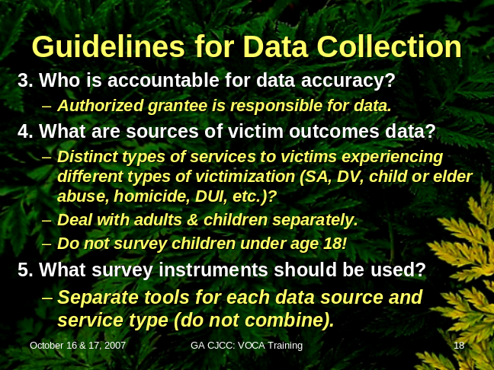The outcome measures that apply to your program will address one or more of those four program purposes (emotional needs, life stability, participation in the justice system, or safety and security). The specific measures are listed in the appropriate data collection instrument for your program. You will find eight such instruments in Appendix B at the end of this Guide.

Where did these measures come from? Georgia’s VOCA and VAWA sub-grantees participated in a ten-month long developmental process to produce the outcome performance measures selected for use in Georgia by CJCC. Advisory groups representing each major type of program developed performance measures they believed were best suited to use in programs like theirs. These were modified further for use by more unique programs. Advisory groups also worked with Performance Vistas and CJCC staff to develop drafts of the instruments in Appendix B and the data collection guidelines in Appendix C. Feedback received from individual sub-grantees was also considered and incorporated in revisions of the performance measures and the data collection guidelines.

The list of required outcome measures for each program or service type is considered a “core” set of outcomes that any program of the type should be attempting to accomplish with CJCC financial support. However, one set of measures will probably not always fit all of your clients! You have to choose which instruments will best fit your service system and your clients:
- Measures for Multiple Program Offerings: Some agencies funded by CJCC are composite programs. They provide similar services (such as sexual assault services) to distinct populations of victims (such as adults and children). Or, they may provide distinct types of services to victims experiencing different types of victimization (sexual assault medical support or domestic violence shelter). Agencies that support multiple programs, such as agencies that function as both rape crisis centers and domestic violence shelters, should not combine the core outcomes into a single questionnaire form. Instead, they should select and use the most appropriate questionnaire for each victim, based on the reason assistance was sought and the services delivered to meet that need. Composite programs that use different survey forms will also have to use separate spreadsheets (to match the survey forms) and separate on-line forms (to match surveys) when reporting their outcome data. This is a logical way of maintaining the integrity of the data within your program and statewide.
- Measures for Programs Serving both Children and Adults: Programs that provide services to adults and to children should use two separate questionnaire forms to collect their outcome data, because the child-specific forms have measures worded for children. The outcome performance measures developed by the Child Advocacy Centers can be used by most of these programs to collect outcome data about children served. Again, these composite programs should use separate spreadsheets and separate on-line forms when reporting their outcome data to maintain the integrity of their data.

Which outcome measurement instruments to use: Your program must use the wording of the sample survey forms in Appendix B. However, you are encouraged to “customize” the layouts of the surveys you use, to make them fit your program’s identity. For example, you may change the fonts, colors, and insert your logo and agency name (or print the survey forms on agency letterhead). You are permitted to include additional measures if your program wants to gather MORE than what is required by CJCC.
RECAP: Editing Your Survey Instruments
You may: Change the fonts, letterhead, “look.”
- Enter the name of your agency.
- Use different forms for different service types or for children and adult clients.
- Add measures or questions to the tool.
- Help the respondent by explaining it or reading it.
You may NOT:
- Change the wording of any measure.
- Change from the standard 5-point scale.
- Delete any measures from the instrument.
- Answer questions on behalf of the victim.

If every program developed its own wording for the required measures, there would be no way to sum up what we learn across the system. Therefore, in order for CJCC to have data sets it can summarize, all programs covered by this procedure are required to use the outcome measures as written in the sample surveys offered in Appendix B. These measures are considered “core” to the outcome measurement strategy. In addition, agencies must use the five-point Likert scale provided by CJCC. “Strongly Agree” is scored 5, “Agree” is scored 4, “Neutral” is scored 3, “Disagree” is scored 2 and “Strongly Disagree” is scored 1. Additionally, some questions have an NA option. If the question has a – in the NA column this means the NA option is not available for that particular question.

Exceptions to wording restrictions on outcome measures: Some of the sample surveys include items that offer options in wording – these options are denoted by a “/” (slash) between the choices. When a slash appears in a sample survey form, you may choose the wording that is more appropriate to your program and the victim or client in question. For example, one measure reads, “My symptoms/reactions, such as sleeplessness, nervousness, fear or anxiety are less severe since I became involved with this agency.” In this case you may change the measure to read “My reactions, such as sleeplessness…” in order to use language most appropriate for your clients.

Your agency may choose to address the core CJCC outcome measures as part of a longer survey, asking additional questions if your agency wishes. If this is the case please make sure all of CJCC’s questions (apart from service quality) go at the start of the survey in the order they are shown. The order of the questions can affect the answers. The service quality questions can go anywhere after CJCC’s questions in the survey. These additional questions are the program’s alone, and should not be reported to the CJCC. (CJCC is only interested in the data coming from similar programs at this time.) If you are thinking of developing a longer survey, or of combining the CJCC outcome measures with another survey your agency already uses, then please follow the Guidelines in Appendix C for making changes to the sample survey instruments.

Satisfaction measures: As explained earlier, satisfaction data are not the same as outcomes data. Generally speaking, CJCC prefers that agencies required to measure outcomes do NOT include their own satisfaction items with the CJCC core outcome measures. Use a separate form for this. The single exception is the one satisfaction item included on all the sample outcome survey forms. That one is, “I am satisfied with the services I received from [your agency name here].” This single satisfaction measure should be collected as part of the outcome survey process. Your program may collect other satisfaction data with any other measures it desires – and at any time it desires – but these data are not to be confused with the satisfaction measure required by CJCC.

- 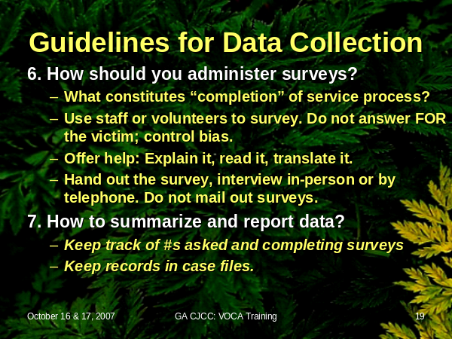Who will provide the data you need, and at what points in the process will you collect data?
Clients of the agency funded by VOCA and VAWA programs will supply the information for outcome measurement. Who is in a better position for sharing what is happening in the life of a crime victim than the victim herself or himself? This is the rationale for using the client self-reported survey forms contained in Appendix B. But sometimes clients cannot speak for themselves, as when a victim is an infant or a disabled adult, or one who cannot read, or one who speaks a language other than English. Your data strategy must account for all these circumstances. Usually this will require your program to have a process in place for asking a caretaker of a disabled adult, or a parent of a child victim, or an advocate of a non-English-speaker to complete the outcome survey. If the client or victim cannot speak for herself, then you want a respondent who speaks for her best interests.

But which clients? The client outcome survey forms should be administered in their entirety to each client with whom your program has more than minimal interaction. Since a program’s services may reinforce each other to produce a total effect on the outcomes experienced by a client, agencies should not try to separate and tie the performance of a specific service to a specific client or measure. Stated another way, an agency cannot expect to separate the outcomes reported by a client and attribute these outcomes to the work of one staff member or of one component of the program over another. This often means that you will be surveying all your clients, and not just those funded by CJCC.

Which clients should NOT receive an outcome survey? Programs funded by CJCC are not required to administer the survey to clients with whom the agency has had minimal contact (telephone call, distribution of information via pamphlet or letter, conduct of a forensic medical exam or forensic interview only). It is difficult to determine the outcome of such brief contact on victims; although it may be significant, it is hard to measure accurately. Agencies should make every effort to collect outcome data from clients receiving more contact than brief interactions.

How should programs gather feedback from those who are not clients, i.e., non-participants? It may be important for your program to ask its agency partners for feedback on how you are doing. If so, that is great leadership. Data collected from other sources (staff, observers, pre- and post-assessment data on standardized instruments, etc.) not specified among the measures listed in Appendix B may provide valuable insights for program management. Programs are encouraged to collect, analyze, and use these data to provide better service to their clients. However valuable these data are, they do not substitute for collecting and reporting the required outcome measures data to CJCC. Your program should not combine what you learn from non-participants with the data you collect from direct service clients.

At what points in the service process are you expected to collect outcomes data? A client cannot report outcomes (i.e., changes in her life) associated with her involvement with your program until her engagement with the program is complete, or substantially complete, as defined by the program’s design (logic model). So, it makes no sense to ask a client about outcomes at or near “intake” to the program. For example, a program’s staff should not share a legal rights brochure, then immediately ask the client whether she now knows more about her rights as a crime victim – she may be expected to learn more about her rights as she talks with other clients, with staff, and throughout her other program activities. The brochure doesn’t ensure she achieves the outcome of knowing her rights, the entire program does. For the same reason it makes no sense to ask about outcomes in the throes of the service process. Even if a shelter resident feels a little bit safer during her first week in shelter, that could change during her second week. It often flips back and forth with circumstances. The program has to have time and opportunity to have an effect on a victim’s situation. Therefore, CJCC wants you to ask for outcome information when the client has substantially completed the program’s services.

What is “substantial completion of services?” That depends on the design of your program, which is one reason you developed your logic model first! Further more, there is a place in the form when you report your outcome data online to CJCC where you will explain the strategy you are using for collecting outcome data. Your strategy has to be consistent with your program’s logic model. You will have to describe how your agency is administering the questionnaire, when the questionnaire is administered, and who is responsible for collecting, compiling, and reporting the data. To help you prepare for this, here are some tips for thinking through how your program design should drive your approach for gathering outcome data.
- Immediate or intermediate outcomes? Obviously “substantial completion” depends on how long your program intends to stay involved with a client. Some crisis intervention programs (e.g., law enforcement victim’s assistance, sexual assault centers) might have their total impact on a client during her first week or two, and may have no further contact with her. For them, the time to have the client complete the outcome survey is just before you see her for the last time. It is not the intent of CJCC to add to the victim’s trauma. Asking outcome questions during the immediate crisis intervention is inappropriate. But most program people who worked on the measures acknowledged that they usually follow up with victims within a week or two of intake; these follow-up contacts are a good opportunity to ask the outcome measures. Some programs are designed for services to last the duration of a crisis period; typically that is around six weeks – and these programs should ask before they expect to see the client for the last time.
- Long term service approaches or intermittent service delivery? Because time delays and other life experiences during longer service periods can alter clients’ perceptions of outcomes, CJCC believes it is better to measure immediate and intermediate outcomes rather than waiting to measure final outcomes after all services are completed. Your program’s design (as described in its logic model) should identify the natural sequence of service delivery and enable you to determine at which point it is most appropriate to collect outcome data from clients after receipt of immediate/intermediate services. Long term approaches, such as therapeutic counseling, are not the types of programs for which this outcome measurement system was designed. If you have a program whose logic model calls for outcomes that cannot be achieved in less than several months, you should be talking with your VOCA, VAWA or SASP grant manager about how to approach outcome measurement.
- Surveying those who come and go: Your program will not be able to have every client stop and complete a survey just before they complete services. Some leave with no advance notice, or go out one day and never come back. Your program will not be held in error by CJCC if you cannot account for EVERY client with an outcome survey. If your staff are taking reasonable steps to ask clients for outcome information before they expect the client to complete services, that will be sufficient for CJCC. Programs offering an array of services may also find it difficult to determine “completion of services” if victims contact a program, receive some services, leave, and then return at a later date for additional services. For example, a victim of family violence may contact a shelter for assistance getting a temporary protection order (TPO). At that point in time, she may not feel she needs emergency shelter because she is staying with a friend. However, after awhile, she needs to stay at the shelter especially if the perpetrator does not respect the TPO. In this type of situation, since a new victimization has occurred, this should be considered a new victim for purposes of administering the outcome survey questionnaire/interview. Each new victimization event (and re-engagement with the program) is a new victim receiving services to be concluded with an outcome survey.
- Surveying those who receive most services early, then are seen intermittently until a later event: Some programs, such as those based in District Attorney’s Offices, may assist victims intermittently. They stay in contact with victims until the trial is scheduled, and provide accompaniment and other services. Then, long delays occur between the initial period of assisting the victim and the eventual trial. Delays like these can affect victims’ perceptions of outcomes. The eventual outcome of the trial can also have an effect on victims’ perceptions of the outcomes of the accompaniment services. CJCC believes it is a more accurate reflection of the impact of services on victims if these victims are asked earlier in the process (before trial or before a verdict or plea). Some Prosecution Victim/Witness Assistance Programs (district attorneys and solicitors) have decided to ask clients to complete the survey at the same time they are notified of their trial/hearing date, since the programs make contact with all victims at this point. This is acceptable to CJCC.
- Administration after trial or legal proceeding: If Prosecution Victim/Witness Assistance Programs want to wait to administer the outcome survey until after a trial, CJCC suggests they add preliminary items to the survey asking the victim about their satisfaction with the trial outcome, the judge, and the prosecutor. This may help counteract the negative impact on client perceptions if the trial outcome is unsatisfactory.
- Integrating data collection into ongoing activities: Program staff should make an effort to incorporate collection of outcome data into an existing program activity, such as an exit interview or other process associated with closing out a case. Making this routine ensures that all staff will become accustomed to the process, and that clients will accept the effort as another step, not a special circumstance. Reminding clients that we are asking these questions to learn how to improve services to serve victims better is an important part of administering the questionnaire or the interview.

3. Who will actually gather the data, and under what circumstances?
Your program has to decide who is in the best position to assist clients with outcome surveys. That might have to be the person who has had the most contact with the client, such as an advocate or counselor. However, if your program can find an alternative, a volunteer or administrative worker might be better, to help the client separate outcome responses from satisfaction issues. Volunteers are a good way to control for respondent bias. This person will also have to deal with language issues, ensure client anonymity, and. Here are some tips for administering the outcome surveys:

- Assisting victims to complete outcome surveys: The survey can be administered in writing or verbally as an interview. Program staff persons should assist clients that have literacy, vision, or other difficulties. Staff may read a form to the clients and may feel secure in explaining what the intent of a question is. Your program’s lead person for outcome data should make sure staff avoid influencing client responses by sticking as closely as possible to the substance of the outcome measure on the survey form. Program staff members should never answer the questions for the client. CJCC is having these forms translated into Spanish; a standard translation is preferred.
- Explaining the survey to victims: Clients should be told that completion of the questionnaire or interview has no impact on their eligibility for services. Clients should feel free to decline to answer any or all of the questions. Clients should be told that the purpose of collecting this information is to improve services to victims of crime. CJCC will not hold it against a program when some clients decline to provide information on an outcome survey.
- Confidentiality of client surveys: Clients should be told that their confidentiality will be protected; their outcome responses will be combined with the answers from all other clients served, and will not be used for identifying any specific client.
- Keeping survey records: Your program should keep all outcome survey questionnaires. If possible, store outcome surveys with other client records. In agencies where records are subject to discovery, these surveys may be kept separately. A unique identifier (name or number) should be placed on all surveys to ensure that data collection and data entry are not duplicated.
- Respondents speaking on behalf of a child: Agencies providing services to children should be administering the survey to a parent, guardian, or CASA or CAC volunteer coordinator, who will complete the survey on behalf of the child. Agencies should avoid administering this survey to a minor child or adolescent (age 18 and under), as these persons cannot give informed consent under law. You should remind the individual completing the survey that the questions ask about the child or about the family and should be answered as much as possible in the interests of the child. Agencies may want to note the relationship between the respondent and the child being served by the agency.
- Tracking completed surveys: Program staff are encouraged to ask all individuals served to complete the outcome survey, but CJCC recognizes that not all victims will agree to do it nor be available to be asked. All agencies should keep track of how many clients are asked to complete surveys, as well as how many actually complete the surveys. The number of clients completing outcome surveys is not expected to be the same as the number of clients who receive services or even complete the service program because some will not agree to complete to the questionnaire, some will not be available to be asked, and some will not receive more than a single service.

4. Who will aggregate the data, analyze it and report it?
CJCC recommends that someone within your program be responsible for collecting the client outcome surveys and recording them in a monthly summary sheet. If your program has no specialized software for this purpose, you may use any tallying method you are comfortable using. Most programs use an administrative staff person who is comfortable with spreadsheets.

Once each semester (by October 30 and April 30) your program is required to log onto the reporting web site hosted by dimensions and supplied by CJCC to record your outcome data. That task might best be managed by the same person who records survey results in the spreadsheets. However, the Executive Director or other authority should maintain control over this process.

Executives of the program should plan on USING the data on an ongoing basis to improve their program’s performance. Chapter Four describes some ways managers can use outcome data to enhance program performance. CJCC is also planning some training on how to use outcome and output data to support staff recruitment, training, supervision, program planning and resources management. You should monitor the CJCC web site for news of this training!

Aggregating outcome data: CJCC has worked with Performance Vistas to prepare Excel spreadsheets for use in compiling your outcome surveys. These Outcome Data Aggregation Spreadsheets were developed expressly for programs like yours. They each cover one year’s outcome data. It’s important that you use the one tailored for your type of program, because the measures you find on your survey forms will match the Excel data summary sheets. Not all surveys or data aggregation forms are the same! These Excel sheets will provide your program with month-by-month and year-to-date totals of the responses your clients have to the outcome questions on the surveys.

The Excel-based Outcome Data Aggregation Spreadsheet files were developed to help Georgia's Crime Victim Assistance Programs summarize their data on client outcomes before reporting the data on the approved online reporting system. You should find it to be a terrific alternative to using pencil and paper checklists.

Please note: There are separate and unique spreadsheets designed expressly for each of the eight major types of programs required to report outcome data to CJCC. Each spreadsheet contains those outcome measures required for that particular type of program. Be sure you are using the one(s) for YOUR type of program! If your program includes multiple components, such as a domestic violence shelter/services program combined with a sexual assault center and/or a child advocacy center, you will need to use more than one spreadsheet to aggregate your outcomes for the various components of your program. MATCH THE SPREADSHEETS TO THE SAMPLE SURVEYS! We are using the CASA sheet for our example in the discussion that follows.

1. Find the Proper Worksheet: There are 15 tabs at the bottom of the screen. The first tab is a set of brief instructions referring to these directions. There are also 14 tabbed worksheets, one for each month: OCT ENTRY. The data ENTRY sheet is labeled, for example, "Oct Entry." This is the sheet you will use for ENTERING your October survey data. The ENTRY sheet is the only place you will enter your actual data from a stack of survey responses each month.
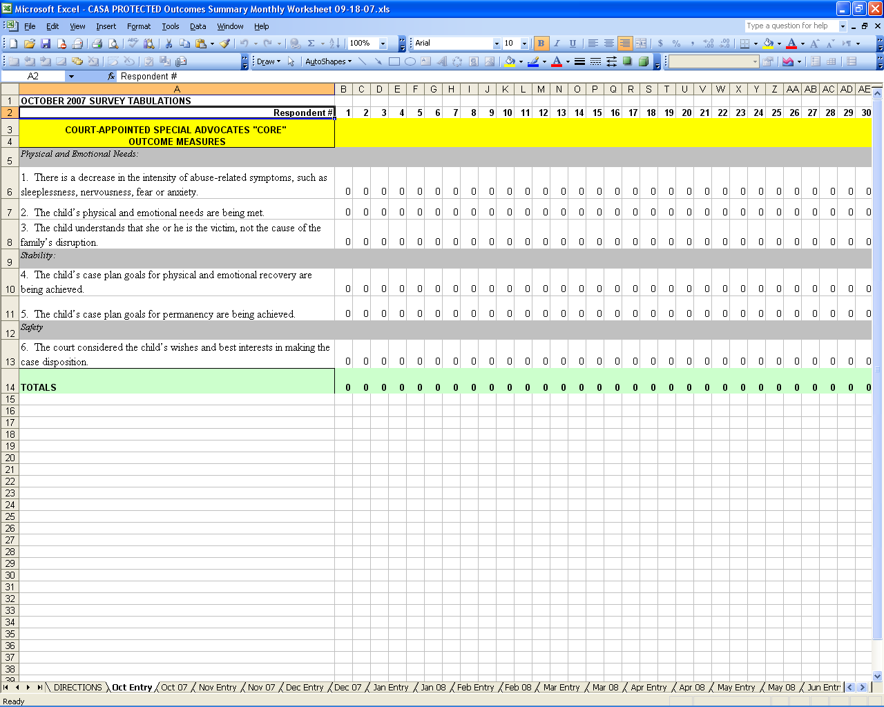

Figure 1. Example of an empty CASA Spreadsheet, showing tabs at bottom for monthly ENTRY and monthly data SUMMARY.

2. What Monthly Data Summaries Look Like: When you enter your survey responses from a stack of client feedback surveys into that month’s ENTRY sheet, it automatically posts your monthly entries to a six month SUMMARY sheet, labeled either, "November-April" or “May-October”. These SUMMARY sheet tally your survey responses, totals the responses and stores the frequencies you will report to the funding agencies online. These sheets are set up for you to enter your agency's profile information, such as the contract number, date of the report, etc., so you can keep a hard copy for your records. (These are in blue font in the example below.) The sheet is set up to prevent you from over-writing an important formula by inadvertently inserting information where it does not go.
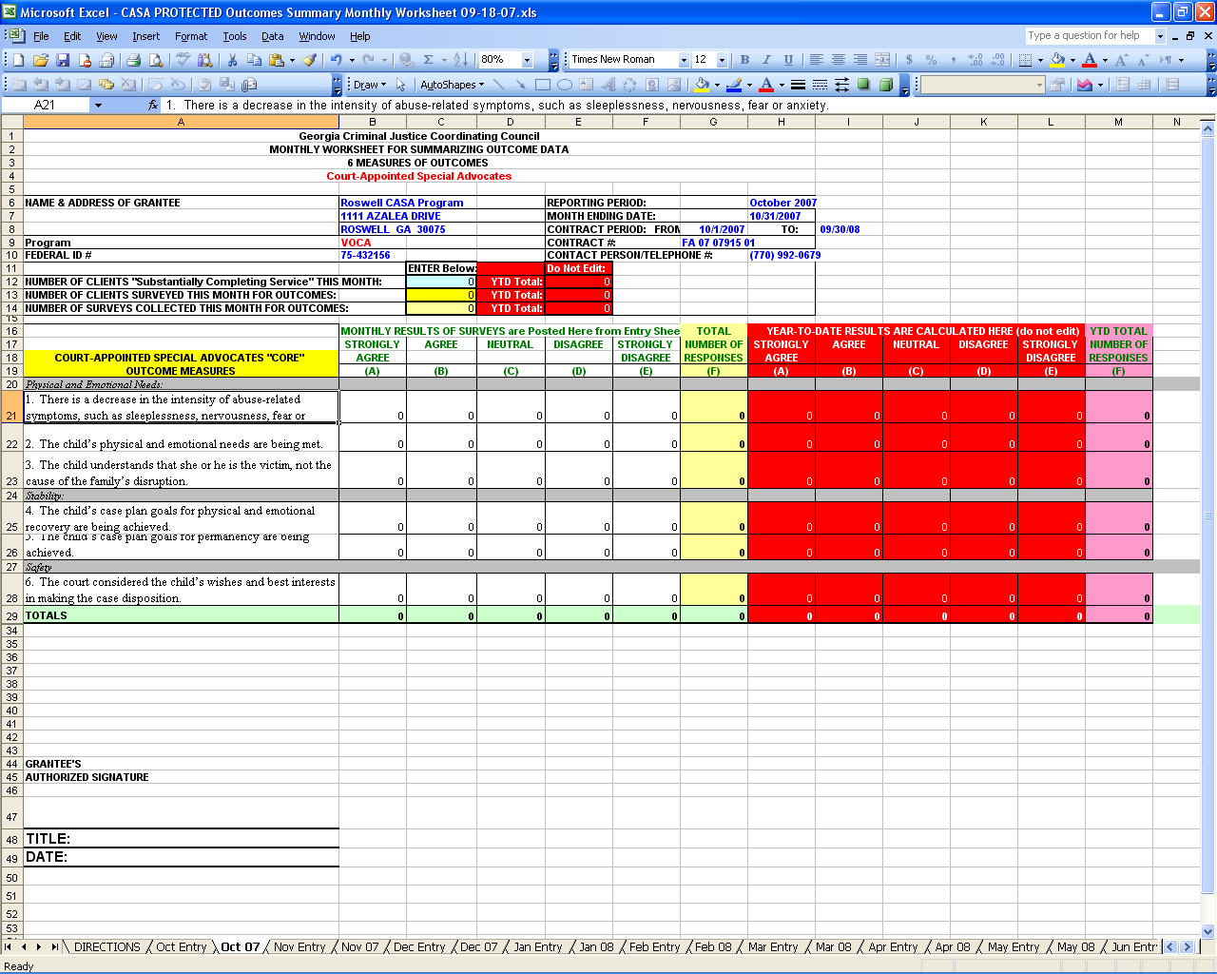

Figure 2. Example of a CASA Spreadsheet, showing monthly data SUMMARY (Oct 07).

3. Entering Monthly Outcomes Data: At the end of each month, you should find and use that month’s data ENTRY sheet. Place your stack of surveys beside the computer and work your way down the stack, completing an entire column in the spreadsheet for each respondent’s survey (i.e., each column is for an individual survey). There are 6 questions for our sample CASA survey, so you would record six responses as you work your way down each column. The sheet will not allow you to enter data into a grayed-out field. Type in the respondent’s answer for each question ("5," "4," "3," "2," or "1") in column 1 for Respondent #1, turn to the next survey form and go down the second column for Respondent #2, etc. If an item was skipped by the respondent, then skip the entry for that item in the sheet. The worksheet will add your responses as you go across to the right entering surveys. It will also automatically post these totals to the monthly SUMMARY sheet for that month.

Each data entry sheet is designed to accommodate as many as 50 survey respondents across fifty columns. Do you have more than fifty survey responses for this month? Contact your CJCC grant administrator, who can help you add more columns or send you a sheet with more columns. DO NOT ATTEMPT TO CHANGE THE FORMULAS, which have been protected to help you avoid inadvertently altering the sheet.

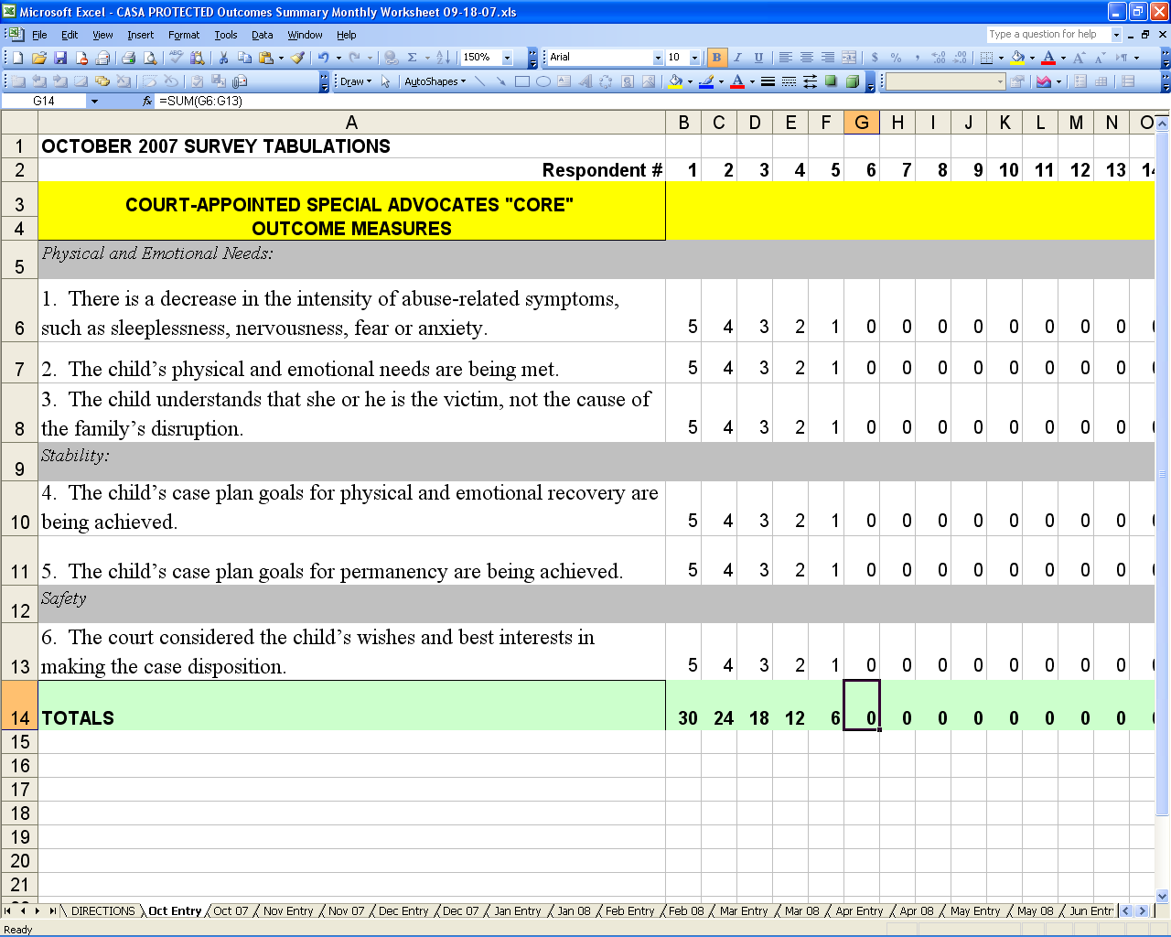

Figure 3. Example of a CASA Spreadsheet, showing monthly data entry for five surveys. Respondent #1 marked all six measures a “5.” Respondent #2 marked all six a “4.” Respondent #3 marked all items “3.” And so on.
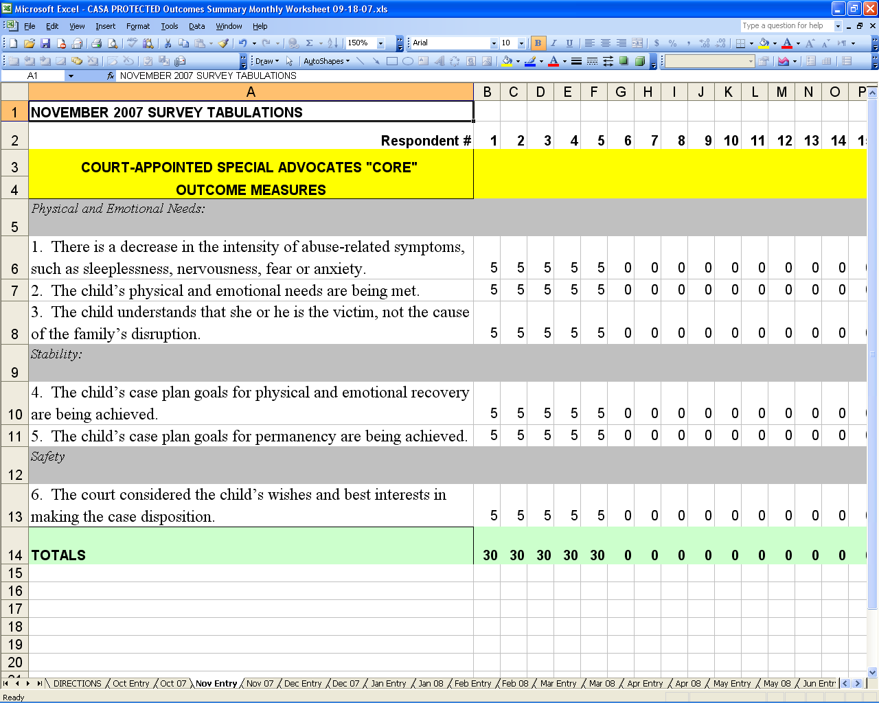

Figure 4. Example of a CASA spreadsheet, showing monthly data entry for five more
surveys in November. All five victims indicated all their responses were “5.”
4. Data Summaries: Each six month summary sheets will reflect all the survey responses you entered for the past six months in the white section, showing the total number of responses for each question that answered "Strongly Agree," "Agree," "Neutral," etc. As you proceed through the months you will see the sheet bringing each new month's totals into the Year-to-Date totals (look for this in the red section).

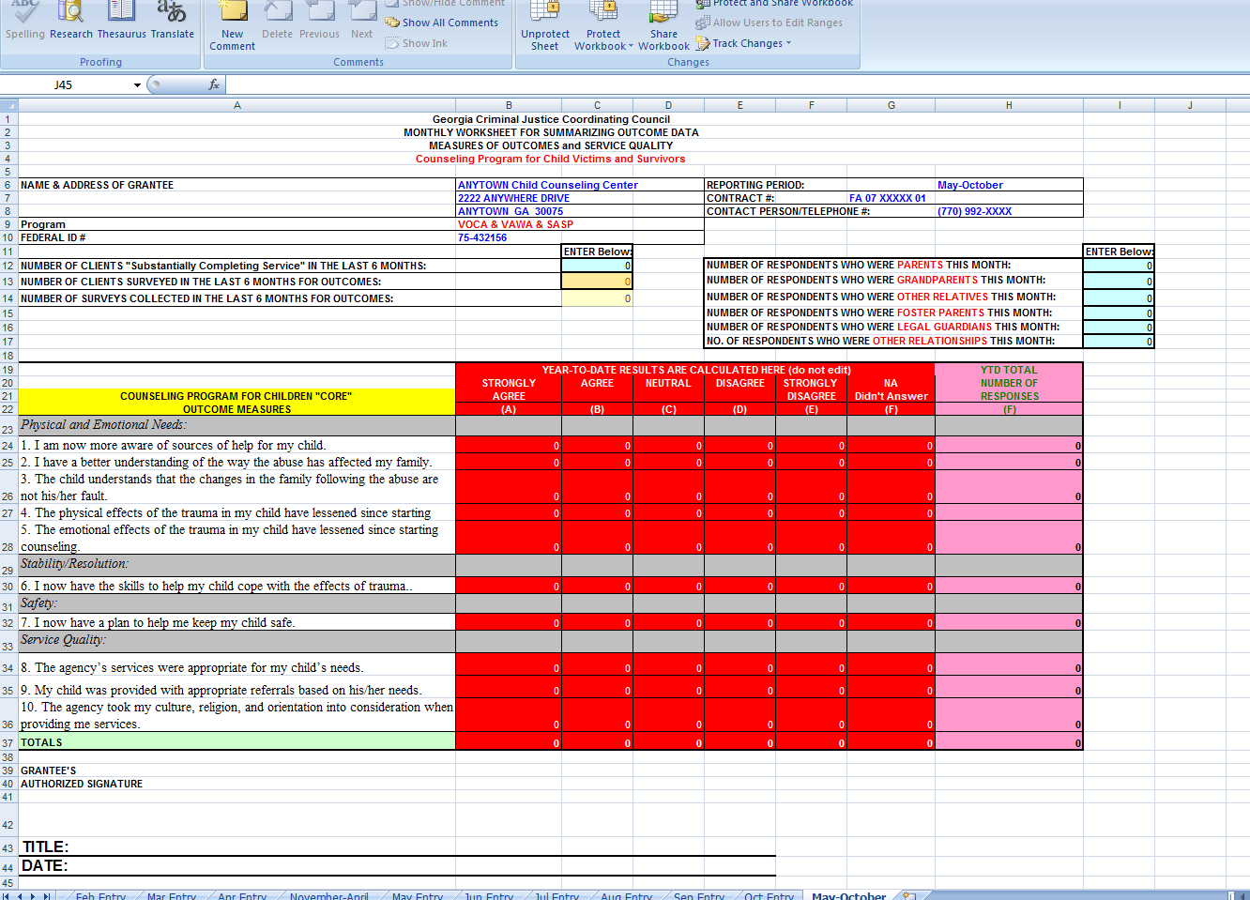

Figure 5. Example of a CASA spreadsheet, showing monthly data summary for the
five October surveys. Note how entries were posted from Oct ENTRY sheet.

5. Printing a Copy for Your Records: As you finish each month's work on the outcome data aggregation spreadsheet, please print a copy of the Summary Sheet for that month. Keep it with your surveys. Share it with program management and training people, so they can try to learn from each month’s client feedback. You may use the data from the previous months internally for staff training or grant applications for other sources of funding). Of course, you will use the Summary Sheet for the sixth month for your semi-annual online outcomes report for Georgia CJCC. You will use the Summary Sheet for the twelfth month for the year-end Outcomes Report for CJCC. All these data collection suggestions are subject to the guidelines on outcome data collection and reporting. If you have questions, you should not hesitate to call your planning person at CJCC.

You should be ready now to give it a try. Pick the correct sheet to match your survey type, then CLICK ON Oct Entry TO BEGIN for the first year’s outcomes data entry!

If you have problems with using the spreadsheet for aggregating your outcome data, you should call your CJCC planning person.

Reporting your Outcome Data
The first report is a first six months report due at the end of May for the data from November 1 through April 30 of the project year. The second report will be for data collected for the second half of the year. It is due on November 30 and is on data from May 1 through October 31. This means that the second report will include only the data reported in the last six-month.

The online addresses for each of the reports will be reported to subgrantees a month before they are due. The email will include links to each of the 10 different surveys. Subgrantees must finish the report once they start because the survey does not allow subgrantees to log back onto wherer they stopped.

Instructions for Logging in to the Reporting Site and Recording your Agency’s Data
Start by clicking on the appropriate link for the report of your type program. Next, enter your agency information, such as the date of the report, your name, your agency’s name, and so forth. You will need your grant numbers for both the VOCA, VAWA and SASP contracts for which you are reporting outcomes. Your reporting period will be one of the six-month period spelled out in the email you received from CJCC.

Number of Victims: Consult your program records and enter the number of clients who “substantially completed” services during the period for which you are reporting. This would typically be the number of clients whose cases were closed during the period, or who exited the program and did not return. This will constitute a “rolling total,” because some people might have completed services who entered the program before the reporting period began.

Number of those targeted victims “substantially completing services” who were offered an opportunity to complete an outcome questionnaire: This is the total number of clients who were surveyed using the outcome questionnaire for this service during this reporting period. How many did your program staff ask to complete the questionnaires? Ideally, this number would match the number of people “substantially completing” services, but there may be some who left before you could ask them to complete an outcome questionnaire.

Data Collection Process: This space is reserved for describing your program’s Outcome Data Collection Strategy. It requests information under eleven questions (A - K) about your design:
A. What staff position does your program assign primary responsibility for collecting outcome data from clients (i.e., clerical support person, volunteer, program administrator, advocate, counselor, etc.)? You may describe your approach in as many words as you need, but this should not be a lengthy entry. The text boxes (A – K) expand to accept your narrative. However, there is no need to enter more than a paragraph for most boxes. Remember, you can cut and paste your narrative from a word processor, as a way of editing and formatting your paragraphs.

B. How does that person usually collect the outcome data from clients? In-person interview, in-person assistance while client completes written questionnaire, over-the-phone interview; clients work independently to complete a questionnaire, other (describe). If client works on questionnaire independently, please explain how the questionnaire is submitted (e.g., handed to staff member, placed in a box before leaving office, etc). Please list all the methods that your program uses, in narrative fashion.

C. At what point in the victim assistance process do you ask the client for outcome data? How do you define “substantial completion of services” in your program? Define what your program design says about “substantial completion” of your program, and explain how you ask clients for outcome feedback at that point in the service process.

D. Have you embedded the required outcome data questions into an existing agency questionnaire (i.e., exit questionnaire, client satisfaction questionnaire)? If yes, please describe that questionnaire briefly. Describe how you have integrated the CJCC “core” outcome measures with other client surveys your agency is conducting.
E. What staff position does your program assign primary responsibility for tallying the outcome data from individual client questionnaires? Describe the position responsible for aggregating the various surveys monthly.

F. What staff position does your program assign primary responsibility for the on-line data reporting to CJCC? Describe the position responsible for logging on to the reporting web site at reporting times.

G. What are you using to tally the individual client outcome data (choose all that apply)? Excel Spreadsheet provided by CJCC; Case Management software (please specify); Tallies by hand; Other (please specify): Describe the methods your agency uses for compiling the data monthly.

H. Where do you store the completed survey instruments or interview forms? The forms should be kept in a secure location, so that program reviewers or auditors may find them.

I. How do you restrict access to the completed survey forms? Describe your methods for safely and securely controlling access to the old survey forms.
J. How are you using the performance data you are collecting? Take the time to share your thoughts and suggestions for CJCC. The funder will use your comments to refine the outcome measurement process.
K. What difficulties have you encountered in collecting and reporting the required performance data? Take the time to share your thoughts and suggestions for CJCC. The funder will use your comments to refine the outcome measurement process.

Entering Counts of Responses for the Reporting Period: Please report the total numbers of respondents who, during the reporting period, answered “Strongly Agree” (5), “Agree” (4), “Neutral” (3), “Disagree” (2) or “Strongly Disagree” (1) to each outcome question in the spaces. Answers are required in each field. You will need to enter a zero (0) if you had no respondents in a scaled category.

Printing and Submitting your Report: Please notice the advice at the bottom of the screen. You should print a copy of your report to keep for your records before you hit the Submit Button, because once submitted your data cannot be retrieved for printing. To print, use your browser’s menu options. Do not simply hit the Print button in the tool bar. Go to “File,” “Print Preview,” then “Print.” This way your copy will not be cut off at the margins.

When you have reviewed your report, you may click on the Submit Button. Your data will be sent to the CJCC via Dimensions. This will allow CJCC to obtain and review the data.

That is all you need to do to report your program’s outcomes data! CJCC will compile the data and prepare summaries to provide you with feedback on how the statewide system is impacting clients of VOCA, VAWA and SASP.

Errors in a Report you have already submitted? When you submit the outcome report the system locks it to keep it from being changed inadvertently. If you realize you made an error after submitting your report, there’s only one way to fix it. First, you must call your CJCC planning person to explain the situation. CJCC staff will then notify the host of the reporting system to re-open it briefly for you to re-submit your report. You will have to fix your error, then submit the entire report again. When you do so, make sure you place the word “REVISED” on the line with your agency’s name. This is so the people hosting the reporting site can tell the difference between this corrected report and the old one. Once that report has been added to the outcomes reporting database the reporting system’s host will delete your old report and the new one will stand as your required report. Obviously, it is much easier to print a copy and review it carefully for errors BEFORE submitting it the first time!

Appendix A. Worksheet and Guidelines for Preparing Your Program’s Logic Model
Figure 1: Sample Logic Model Planning Worksheet
PURPOSE: (also known as “Problem Statement,” or “Needs Analysis”) It helps define what we want for success:

INPUTS | OUTPUTS  (These are the things we must DO and PRODUCE, in order to be successful. Some include our collaborators or partners – to help identify who benefits from outcomes.) |  | OUTCOMES  (How would we know we were being successful?) (Must be defined in terms of Purpose, which is why we need a Logic Model!)
INPUTS | Activities  (What must we DO?) | Partners  (Who benefits? Who are the “customers”?) | Short-Term | Intermediate | Long-Term
Figure 2: Simple Logic Model for Planning & Having a Holiday Party (Tips in italics for preparing your own program design…)
PURPOSE: (also known as “Problem Statement,” or “Needs Analysis”) It helps define what we want for success:
Might be a kids’ party, a house party or an office party.
INPUTS  Money  Co-Hosts  Volunteers  A Place for the Party  Providers (e.g., caterers, the band or DJ, etc.)  Sometimes a listing of activities will include some things labeled at first as “activities” that need to be moved to this column. The difference between an input and an activity might depend on who performs it. For example, if the party budget won’t allow you to purchase the services of a DJ (input) you might have to play your own CD collection (activity). | OUTPUTS  (These are the things we must DO and PRODUCE, in order to be successful. Some include our collaborators or partners – to help identify who benefits from outcomes.) |  | OUTCOMES  (How would we know we were being successful?) (Must be defined in terms of Purpose, which is why we need a Logic Model!)
 | Activities  (What must we DO?) | Partners  (Who benefits? Who are the “customers”?) | Short-Term | Intermediate | Long-Term
 | Decide the party’s date  Make up a guest list  Prepare invitations  Plan the menu  Plan the bar  Go shopping  Clean the house  (These last two might force clarifying the party’s purpose – house or office?)  Decorate; Find a DJ  Greet guests  Mingle, referee, monitor to make sure people are having fun; and that food and drink are holding up  Fix more food; go get ice  Say good bye  Clean up the place  (Build this list as it comes up. THEN move ideas around to put the process in sequence by numbering them or drawing arrows between them.) | Guests  Co-Hosts  Family  Self  Neighbors (uninvited people, who would like a quiet and orderly affair)  -- OR, if an Office Party:  Co-Workers  The Boss  Business Partners  Vendors (if you are inviting them as guests; if they are there as paid contributors, like the band or the caterers, they are INPUTS) | People have fun  People relax  People meet new friends  Length of party  No one goes to jail!  Compliments on how well things are going | People talk about it  People start wanting next year’s invitation  Ask for recipes  Make new friendships  Good will with business partners  Find new customers  Better communica-tion | People ask you to please host the party next year!  New friendships turn into long-term ones; some get married, have kids and name them after you!  Invited to start a new party planning business

Appendix B: Sample Outcome Survey Instruments

Domestic Violence Shelter & Services Survey

As a result of the services I received from [your agency name here]: | Strongly Agree | Agree | Neutral | Disagree | Strongly Disagree | NA
Physical and Emotional Needs:  - I now have a better understanding of domestic violence.  - I am now more aware of other sources of help available to me.  - I now feel more confident about managing the effects of domestic violence on me. | 5  5  5 | 4  4  4 | 3  3  3 | 2  2  2 | 1  1  1 | -  -  -
Stability/Resolution:  - I now know ways to manage my safety.  - I am achieving the goals I set for myself. | 5  5 | 4  4 | 3  3 | 2  2 | 1  1 | -  -
Safety  - I am better able to recognize signs of increased danger in my relationship.  - I now have a plan of action if I begin to feel unsafe in my relationship. | 5  5 | 4  4 | 3  3 | 2  2 | 1  1 | -  -
Understanding/Participating in the Criminal Justice System  - I have a better understanding of how a Domestic Violence case is handled through the investigation until the judge’s decision.  - I now have a better understanding of my rights as a victim of crime. | 5  5 | 4  4 | 3  3 | 2  2 | 1  1 | NA  NA
Service Quality  - I was provided with appropriate referrals based on the needs we identified.  - The services I received from [AGENCY NAME] met my needs.  - The agency took my culture, religion, and orientation into consideration when providing me services. | 5  5  5 | 4  4  4 | 3  3  3 | 2  2  2 | 1  1  1 | -  -  -
Directions: Please help us to improve our program by answering the following thirteen questions. We want to know how you are doing with your recovery process, and how we have helped. Just circle the best answer for each question.

Thank you for taking the time to help us improve our services.

Sexual Assault Centers Survey

Directions: Please help us to improve our program by answering the following ten questions. We want to know how you are doing with your recovery process, and how we have helped.
As a result of the services I received from [your agency name here]: | Strongly Agree | Agree | Neutral | Disagree | Strongly Disagree | NA
Physical and Emotional Needs:  - I now have a better understanding of the effects of the sexual assault.  - I understand that the sexual assault was not my fault.  - I am now more aware of other sources of help available to me.  - The information I received after the medical exam helped me know what I needed to do to take care of my health. | 5  5  5  5 | 4  4  4  4 | 3  3  3  3 | 2  2  2  2 | 1  1  1  1 | -  -  -  NA
Stability/Resolution:  - I have the support of others to help me cope with all the effects of the sexual assault. | 5 | 4 | 3 | 2 | 1 | -
Understanding/Participating in the Criminal Justice System  - I have a better understanding of how a criminal case is processed from the investigation until the final decision.  - I now have a better understanding of my rights as a victim of crime. | 5  5 | 4  4 | 3  3 | 2  2 | 1  1 | NA  -
Service Quality  - I was provided with useful referrals based on the needs identified.  - I felt like my advocate was there to accompany me to appointments related to my case.  - The agency took my culture, religion, and orientation into consideration when providing me services. | 5  5  5 | 4  4  4 | 3  3  3 | 2  2  2 | 1  1  1 | -  -  -
Just circle the best answer for each question.

Thank you for taking the time to help us improve our services.

Adult Victim or Survivor Counseling Client Survey

As a result of the services I received from [your agency name here]: | Strongly Agree | Agree | Neutral | Disagree | Strongly Disagree | NA
Physical and Emotional Needs:  - I now have a better understanding of how being a survivor of crime has affected my life.  - I now know where to go for help if I need additional services.  - The physical effects of the trauma have lessened since starting counseling.  - The emotional effects of the trauma have lessened since starting counseling. | 5  5  5  5 | 4  4  4  4 | 3  3  3  3 | 2  2  2  2 | 1  1  1  1 | -  -  NA  NA
Stability/Resolution:  - I now have the skills to cope with the effects of the trauma.  - I am achieving my counseling goals. | 5  5 | 4  4 | 3  3 | 2  2 | 1  1 | -  -
Safety  - I now have a plan to help me stay safe. | 5 | 4 | 3 | 2 | 1 | -
Service Quality  - The agency’s services were appropriate for my needs.  - I was provided with appropriate referrals based on my needs.  - The agency took my culture, religion, and orientation into consideration when providing me services. | 5  5  5 | 4  4  4 | 3  3  3 | 2  2  2 | 1  1  1 | -  -  -
Directions: Please help us to improve our program by answering the following ten questions. We want to know how you are doing with your recovery process, and how we have helped. Just circle the best answer for each question.

Thank you for taking the time to help us improve our services.

Prosecution Victim Witness Assistance Program Survey

Directions: Please help us to improve our program by answering the following nine questions. We want to know how you are doing with your recovery process, and how we have helped. Just circle the best answer for each question.
As a result of the services I received from [your agency name here]: | Strongly Agree | Agree | Neutral | Disagree | Strongly Disagree | NA
Understanding/Participating in the Criminal Justice System  - I now have a better understanding of my role in the court process.  - Being able to provide input in the court process made me feel included.  - I now have a better understanding of my rights as a victim of crime. | 5  5  5 | 4  4  4 | 3  3  3 | 2  2  2 | 1  1  1 | -  -  -
Service Quality  - I was notified of important information about my case.  - I had an opportunity to provide input before decisions were made in my case.  - I was provided with assistance to complete a victim’s compensation application.  - I was assisted in obtaining restitution from the offender for the financial losses I suffered because of the crime  - I was provided with appropriate referrals based on my needs.  - The agency took my culture, religion, and orientation into consideration when providing me services. | 5  5  5  5  5  5 | 4  4  4  4  4  4 | 3  3  3  3  3  3 | 2  2  2  2  2  2 | 1  1  1  1  1  1 | -  -  NA  NA  -  -

Thank you for taking the time to help us improve our services.

Law Enforcement Victim Witness Assistance Program Survey

Directions: Please help us to improve our program by answering the following ten questions. We want to know how you are doing with your recovery process, and how we have helped. Just circle the best answer for each question.
As a result of the services I received from [your agency name here]: | Strongly Agree | Agree | Neutral | Disagree | Strongly Disagree
Stability  - Getting immediate answers to my concerns after the incident helped me feel less anxious. | 5 | 4 | 3 | 2 | 1
Understanding/Participating in the Criminal Justice System  - I now have a better understanding of my role in the investigation process.  - I now have a better understanding of my rights as a victim of crime.  - Being able to provide information, made me feel my input was important. | 5  5  5 | 4  4  4 | 3  3  3 | 2  2  2 | 1  1  1
Safety  - Being up to date on the offender’s status helped me manage my safety | 5 | 4 | 3 | 2 | 1
Service Quality  - I was notified of important information about my case.  - I had an opportunity to provide my input before decisions were made in my case.  - The law enforcement officers I spoke with knew how to handle a case like mine.  - I was provided with appropriate referrals based on the needs we identified.  - The agency took my culture, religion, and orientation into consideration when providing me services. | 5  5  5  5  5 | 4  4  4  4  4 | 3  3  3  3  3 | 2  2  2  2  2 | 1  1  1  1  1

Thank you for taking the time to help us improve our services.

Legal Advocate Client Survey

As a result of the services I received from [your agency name here]: | Strongly Agree | Agree | Neutral | Disagree | Strongly Disagree | NA
Stability/Resolution:  - Obtaining legal advocacy made it easier for me to regain a sense of control over my life. | 5 | 4 | 3 | 2 | 1 | -
Safety:  - I feel safer because of the legal remedies the advocate helped me get. | 5 | 4 | 3 | 2 | 1 | -
Understanding/Participating in the Criminal Justice (Legal) System  - I now have a better understanding of my role in the legal process.  - I now have a better understanding of my rights as a victim of crime. | 5  5 | 4  4 | 3  3 | 2  2 | 1  1 | -  -
Satisfaction  - Legal Advocate gave me the information I needed to advocate for myself in court hearings.  - The Legal Advocate gave me appropriate referrals to the legal issues I faced as a result of the crime.  - The agency took my culture, religion, and orientation into consideration when providing me services. | 5  5  5 | 4  4  4 | 3  3  3 | 2  2  2 | 1  1  1 | -  -  NA
Directions: Please help us to improve our program by answering the following seven questions. We want to know how you are doing with your recovery process, and how we have helped. Just circle the best answer for each question.

Thank you for taking the time to help us improve our services.

Legal Services Client Survey

As a result of the services I received from [your agency name here]: | Strongly Agree | Agree | Neutral | Disagree | Strongly Disagree | NA
Stability/Resolution:  - Obtaining legal help made it easier for me to regain a sense of control over my life. | 5 | 4 | 3 | 2 | 1 | -
Understanding and Participation in the Criminal Justice (Legal) System  - I now have a better understanding of my role in the legal process  - I now have a better understanding of my rights as a victim of crime.  - I now have a better understanding of my role in the immigration process. | 5  5  5 | 4  4  4 | 3  3  3 | 2  2  3 | 1  1  1 | -  -  NA
Satisfaction  - The attorney/BIA Representative on my case explained to me the laws that apply to my case.  - The services the agency provided were timely.  - The agency took my culture, religion, and orientation into consideration when providing me services. | 5  5  5 | 4  4  4 | 3  3  3 | 2  2  2 | 1  1  1 | -  -  -
Directions: Please help us to improve our program by answering the following eight questions. We want to know how you are doing with your recovery process, and how we have helped. Just circle the best answer for each question.

Thank you for taking the time to help us improve our services.

Survey for Child Advocacy Centers and Sexual Assault Centers treating children [more immediate services]

Primary Caregiver with Best Interests of the Child At Heart

Directions: Please help us to improve our program by answering the following twelve questions. We want to know how you are doing with your recovery process, and how we have helped. Just circle the best answer for each question.
My relationship to the child is (check one): | - parent  - grandparent  - other relative  - foster parent  - legal guardian |  | - Other(describe):
As a result of the services the child received from [your agency name here]: | Strongly Agree | Agree | Neutral | Disagree | Strongly Disagree | NA
Physical and Emotional Needs:  - I am now more aware of other sources of help for the child in my community.  - I have a better understanding of the way the abuse has affected my family | 5  5 | 4  4 | 3  3 | 2  2 | 1  1 | -  -
Stability/Resolution:  - I now have resources to help the child cope with the abuse.  - I now have resources to help the non-offending caregiver cope with the abuse.  - I now have the resources to help the victim’s siblings cope with the abuse. | 5  5  5 | 4  4  4 | 3  3  3 | 2  2  2 | 1  1  1 | -  -  NA
Understanding/Participating in the Criminal Justice System  - I have a better understanding of a criminal case from the investigation until the judge’s decision.  - I now have a better understanding of the rights of child abuse victims. | 5  5 | 4  4 | 3  3 | 2  2 | 1  1 | -  -
Safety  - I now know how to keep the child safe. | 5 | 4 | 3 | 2 | 1 | -
Service Quality  - I did not have to repeat the child’s story to multiple parties since coming to the CAC.  - The advocacy center remained knowledgeable about the status of the child’s case.  - The resources I received helped me cope with the effects of the abuse the child experienced.  - The agency took my culture, religion, and orientation into consideration when providing me services. | 5  5  5  5 | 4  4  4  4 | 3  3  3  3 | 2  2  2  2 | 1  1  1  1 | -  -  -  -

- Prior to coming to the CAC I had to tell the child’s story how many times?

- Since coming to the CAC I have had to tell the child’s story how many?

Thank you for taking the time to help us improve our services.

Survey for Family or Child Counseling Programs
[longer term services]

Directions: Please help us to improve our program by answering the following nine questions. We want to know how you are doing with your recovery process, and how we have helped. Just circle the best answer for each question.
My relationship to the child is (check one): | - parent  - grandparent  - other relative  - foster parent  - legal guardian |  | - Other(describe):
As a result of the services the child received from [your agency name here]: | Strongly Agree | Agree | Neutral | Disagree | Strongly Disagree | NA
Physical and Emotional Needs:  - I am now more aware of sources of help for my child.  - I have a better understanding of the way the abuse has affected my family.  - The child understands that the changes in the family following the abuse are not his/her fault.  - The physical effects of the trauma in my child have lessened since starting counseling.  - The emotional effects of the trauma in my child have lessened since starting counseling. | 5  5  5  5  5 | 4  4  4  4  4 | 3  3  3  3  3 | 2  2  2  2  2 | 1  1  1  1  1 | -  -  -  NA  NA
Stability/Resolution:  6. I now have the skills to help my child cope with the effects of trauma. | 5 | 4 | 3 | 2 | 1 | -
Safety  - I now have a plan to help me keep my child safe. | 5 | 4 | 3 | 2 | 1 | -
Service Quality  - The agency’s services were appropriate for my child’s needs.  - My child was provided with appropriate referrals based on his/her needs.  - The agency took my culture, religion, and orientation into consideration when providing me services. | 5  5  5 | 4  4  4 | 3  3  3 | 2  2  2 | 1  1  1 | -  -  -

Thank you for taking the time to help us improve our services.

Court-Appointed Special Advocates Survey

Directions: Please help us to improve our program by answering the following nine questions. We want to know how you are doing with your recovery process, and how we have helped. The Volunteer Coordinator/program staff that oversees the CASA for each child’s case should fill out the questionnaire. Just circle the best answer for each question.
As a result of the services the child received from [your agency name here]: | Strongly Agree | Agree | Neutral | Disagree | Strongly Disagree
Physical and Emotional Needs:  - The appropriate service providers were alerted the child’s needs.  - The child understands that she or he is not the cause of the family’s disruption. | 5  5 | 4  4 | 3  3 | 2  2 | 1  1
Stability/Resolution:  - The child’s case plan goals for recovery are being achieved.  - The child’s case plan goals for permanency are being achieved. | 5  5 | 4  4 | 3  3 | 2  2 | 1  1
Safety  - The child is currently placed in a situation that closely matches his/her best interest.  - The Child’s final placement is safe. | 5  5 | 4  4 | 3  3 | 2  2 | 1  1
Service Quality  - The CASA volunteer has had regular contact with the child.  - The child’s case was reviewed on a timely manner.  - The agency took my culture, religion, and orientation into consideration when providing me services. | 5  5  5 | 4  4  4 | 3  3  3 | 2  2  2 | 1  1  1

Thank you for taking the time to help us improve our services.

.

Appendix C. Tips for Developing Survey Instruments

This Appendix should help you “customize” your outcome survey instruments without violating CJCC’s guidelines for using the “core” outcome measures. You want to develop surveys using your own items, but you want them to be as effective as the ones developed by CJCC for measuring outcomes. Question writing is more an art than a science. It takes skill, practice, and creativity. We offer the following tips if you are considering adding other questions or items to the items required by CJCC.

- The questions you ask should be relevant to the outcomes of service. If you want to measure satisfaction with the amenities provided by your agency –i.e., the quality of the paper towels in the wash room -- you should administer another questionnaire. Such a question is not relevant to the outcome of service.
- Questionnaires should be as short as possible. This is a practical consideration. You can imagine that if a questionnaire consists of 10 pages and will take the respondent one hour to complete the questions, only a few people will have the patience and time to answer. Therefore, weigh carefully any other questions you might want to add. So…
- Don’t ask too many questions!
- Don’t collect more data than you need!
- Don’t try to report on everything you know – or your participants know!
- Do focus on what is important – outcomes of service.
- When adding additional questions, avoid changing the value direction of response scales. If at all possible, the positive or negative value of the response should always be stated in the same direction, e.g., Strongly Agree, Agree, Neutral, Disagree, and Strongly Disagree or Strongly Disagree, Disagree, Neutral, Agree, and Strongly Agree. It is fair – and indeed appropriate – to use different response types such as Yes/No, True/False, etc. However, do not mix value direction when using these response scales either.
- Additionally, when adding questions to the survey make sure CJCC’s questions (apart from service quality) are at the beginning of the survey and in the order show. The service quality questions can go anywhere in the survey after CJCC’s other questions.
- When using a Likert Scale, make certain that the response scale is “balanced” – the response scale has the same number of response choices that are positive as are negative.
- Avoid mixing the response choices (satisfaction, agreement, etc.) within the question sequence. This will confuse and frustrate the respondents. Instead, group your Yes/No questions together, and your True/False questions together, and place your open-ended questions at the end.
- Use closed questions with standardized responses as much as possible. While open-ended questions allow a more exhaustive list of response possibilities, questionnaires with open-ended items take longer to administer and are difficult to analyze.
- Avoid “double-barreled” questions. Make each question about one and only one topic. A double-barreled question consists of two or more questions joined together. This type of question makes the respondents’ task more difficult and the answers to these questions more ambiguous to interpret.
- Avoid leading questions. A leading question is one that leads the respondent to choose one response over another by its wording. Leading questions are actually statements disguised as questions and make respondents feel that only one response is legitimate. For example, the question “Don’t you agree that you are very satisfied with the services provided by this agency.”

Remember, a good survey will collect data that informs your organization about the degree to which it did or did not achieve its intended outcomes.
Appendix D: CJCC Guidelines for Data Collection
Outcome Performance Measures: VOCA, VAWA, and SASP

Background: Beginning with the 2007-2008 grant year, the Criminal Justice Coordinating Council began requiring its VOCA (Victims of Crime Act) and its STOP VAWA (Violence Against Women) sub-grantees to collect outcome data from their clients receiving direct services. In 2009 CJCC revised the measures to simplify them somewhat.

CJCC is collecting outcome performance data to meet federal and state reporting requirements and to provide sub-grantees with information they can use to improve their programs and report to other funding agencies. Outcome performance data will not be used by CJCC to compare one agency with another, but will be used to monitor programs over time.
- Which programs are affected? This requirement applies only to sub-grantees delivering direct services to clients who are victims of crime and whose contact with clients is more extensive than a single telephone call or other distribution of information (hotlines).
- VOCA, VAWA, and SASP-funded sub-grantees that do not provide direct services to clients are exempt at present from this requirement. Excluded from this project are training projects, special projects such as fatality reviews, coalitions, and investigative units. CJCC will work with these sub-grantees to identify meaningful outcome performance measures for these types of projects at a later date.
- How are statistical reports affected? The collection of outcome performance data DOES NOT replace the collection of statistical reports or annual reports that provide counts of victims served, services delivered, and narrative descriptions of program activities and accomplishments. All previous guidelines, forms, and deadlines for statistical reports (quarterly) and the annual report for VOCA, VAWA and SASP sub-grantees remain in effect as a condition of award.
- Project History: VOCA and VAWA sub-grantees participated in a ten-month long developmental process coordinated by Performance Vistas, Inc., to produce the required outcome performance measures. Advisory groups representing each major type of program developed their own performance measures. These were modified further for use by the sub-types and more unique programs. The Advisory Groups also worked with Performance Vistas and CJCC staff to develop the initial and subsequent drafts of these data collection guidelines. Feedback received from individual sub-grantees has also been considered and incorporated as appropriate in revisions of the performance measures and the data collection guidelines.
  - Performance Vistas has developed electronic spreadsheet applications for sub-grantees to use to enter and aggregate individual data from clients. The CJCCP has developed on-line reporting forms for sub-grantees to use to report aggregate outcome data. The initial pilot of the measures, the data collection processes, and the reporting tools was from June 1, 2007 through August 31, 2007. This period was extended to October 15, 2007. The system was tested again in 2007-08. Since October 2008 the requirements and the reporting have been “live.” CJCC continues to review the data, and is attempting to make the data more and more reliable. The surveys we once again updated in 2012 and data collection resumed November 2012.
  - Additional training sessions have been held to enable all sub-grantees to learn about the performance measures, the data collection guidelines, the electronic spreadsheets, and the on-line reporting system. Most recently, self-paced training modules were posted on the CJCC web site for downloading in late 2010.

1. Outcome Performance Measures: The outcome performance measures reflect the four core functions or purposes for the VOCA and VAWA grants included in the definition of services to victims of crime. As defined in the VOCA Program Guidance,
“services are defined as those efforts that (1) respond to the emotional and physical needs of crime victims; (2) assist primary and secondary victims of crime to stabilize their lives after a victimization; (3) assist victims to understand and participate in the criminal justice system; and (4) provide victims of crime with a measure of safety and security such as boarding-up broken windows and replacing or repairing locks.”
An additional performance measure for customer satisfaction was also developed for every type of program. Copies of the performance measures, by program type, are attached. These questionnaire forms reflect all input received and revisions made up to September 30, 2009.

“Core” Measures are required: The list of required outcome measures for each program/service type is considered a “core” set of outcomes that any program of the type should be attempting to accomplish with CJCC financial support.
  - Measures for Multiple Program Offerings: Some agencies funded by the CJCC are composite programs: they provide similar services to distinct populations of victims (adults and children) and/or may provide distinct types of services to victims experiencing different types of victimization (sexual assault and domestic violence). Agencies that support multiple programs, such as agencies that function as both rape crisis centers and domestic violence shelters should not combine the core outcomes into a single questionnaire form. Instead, they should select and use the most appropriate questionnaire for each victim, based on the reason assistance was sought and the services delivered to meet that need. These composite programs also should use separate spreadsheets and separate on-line forms when reporting their outcome data to maintain the integrity of their data.
  - Measures for Programs Serving both Children and Adults: Programs that provide services to adults and to children should use two separate questionnaire forms to collect their outcome data. The outcome performance measures developed by the Child Advocacy Centers can be used by most of these programs to collect data about children served. Again, these composite programs should use separate spreadsheets and separate on-line forms when reporting their outcome data to maintain the integrity of their data.

Outcome Measurement Instruments: Agencies are required to use the core outcome measures as written. Several surveys include items that offer options in wording – these options are denoted by a “/” (slash) between the choices. You do not have to use both, you can choose the wording that is more appropriate to your program and the victim/client in question. Items also can be modified to insert the name of your agency. Agencies must use the five-point Likert scale provided by CJCC. Strongly Agree is scored 5, Agree is scored 4, Neutral is scored 3, Disagree is scored 2 and Strongly Disagree is scored 1. Agencies can reformat the items using any font or any layout style, as long as the wording and ordering is not changed and the 5-point Likert Scale is used as scored above. The core outcome measures can be included on a longer survey asking additional questions if the agency wishes. These additional questions will not be reported to the CJCC.

Satisfaction Measures: Data should be collected on the required satisfaction measure as part of the outcome survey process. Agencies may collect other satisfaction data with any other measures they desire – and at any time they desire – but these data are not to be confused with the satisfaction measure required by CJCC.

2. Survey Questionnaire/Interview Administration: The survey should be administered in its entirety to each client. Since a program’s services may reinforce each other to produce a total effect yielding the outcomes intended, agencies should not try to link performance of a specific service to a specific item. Nor should a program attempt to collect outcome data before the program has been substantially completed. For example, CJCC does not encourage a program’s staff to share a legal rights brochure and then immediately ask the client whether she now knows more about her rights as a crime victim. This is the reason the guidelines require gathering outcome data upon “substantial completion of services.”

- Assisting victims to complete feedback instruments: The survey can be administered in writing or verbally as an interview. Agencies are encouraged to assist clients that have literacy, vision, or other difficulties, and may explain what the intent of the question is. Agencies are encouraged to control for influencing client responses by sticking as closely as possible to the substance of the outcome question. However, agencies should not answer the questions for the client. CJCC will be getting these forms translated into Spanish; a standard translation is preferred.
- Explaining the survey to victims: Clients should be told that completion of the questionnaire or interview has no impact on their eligibility for services, and all clients may decline to answer any or all of the questions. Clients should be told that the purpose of collecting this information is to improve services to victims of crime.
- Confidentiality of Client Surveys: Clients should be told that their confidentiality will be protected. Clients can be informed that the results are reported as aggregate numbers (all responses combined from all clients served).
- Keeping survey records: Outcome survey questionnaires should be kept by the agency, preferably with other client records. In agencies where records are subject to discovery, these surveys can be kept separately. A unique identifier (name or number) should be placed on all surveys to ensure that data collection and data entry are not duplicated.
- Controlling for bias: Agencies are encouraged to identify a person who is not the primary service provider for that client (such as a volunteer or administrative worker) to ask the questions and document the client’s answers. However, if no one else is available to administer the survey, the advocate or counselor should do it.
- Respondents speaking on behalf of a child: Agencies providing services to children should be administering the survey to a parent, guardian, or CASA or CAC volunteer coordinator, who will complete the survey on behalf of the child. Agencies should avoid administering this survey to a minor child or adolescent (age 18 and under), as these persons cannot give informed consent under law. You should remind the individual completing the survey that the questions ask about the child or about the family and should be answered to the best of their ability. Agencies may want to note the relationship between the respondent and the child being served by the agency.
- When NOT to do a survey: Agencies are not required to administer the survey to clients with whom the agency has had minimal contact (telephone call, distribution of information via pamphlet or letter, conduct of a forensic medical exam or forensic interview only). It is difficult to determine the outcome of such brief contact on victims; although it may be significant, it is hard to measure accurately. Agencies should make every effort to collect outcome data from clients receiving more extensive services.
- Tracking completed surveys: Program staff are encouraged to ask all individuals served to answer the outcome questionnaire, but CJCC recognizes that not all victims will agree to do it nor be available to be asked. All agencies should keep track of how many clients are asked to complete surveys, as well as how many actually complete the surveys. The number of clients completing outcome surveys is not expected to be the same as the number of clients who receive services or even complete the service program because some will not agree to complete to the questionnaire, some will not be available to be asked, and some will not receive more than a single service.

3. Timing of Data Collection: Agencies should collect the data on the core outcome measures from each client at the substantial completion of their program of service, as described in their program’s design (“logic model”). Some programs are focused on delivering services within a brief period of time (law enforcement victim’s assistance, sexual assault centers); once that time has passed, they may no longer have contact with the victim. It is not the intent of CJCC to add to the victim’s trauma. Asking these questions during the immediate crisis intervention is inappropriate. However, most agencies acknowledged that they usually follow up with victims in a week or two; these follow-up contacts are a good opportunity to ask the outcome measures.
  - Integrating Data Collection into On-Going Activities: Agencies should make an effort to incorporate collection of outcome data into an existing program activity, such as an exit interview or other process associated with closing out a case. Making this routine ensures that all staff will become accustomed to the process, and that clients will accept the effort as another step not a special circumstance. Reminding clients that we are asking these questions to learn how to improve services to serve victims better is an important part of administering the questionnaire or the interview.
- Intermittent Service Delivery: Other programs may deliver services over time, continuously or with long intervals between delivery of services. Because time delays and all the other intervening life experiences during that period can alter clients’ perceptions, CJCC believes it is better to measure immediate and intermediate outcomes rather than waiting to measure final outcomes after all services are completed. Your program’s design (as described in its logic model) should identify the natural sequence of service delivery and enable you to determine at which point it is most appropriate to collect outcome data from clients after receipt of immediate/intermediate services.
- Surveying those who come and go: Programs offering an array of services may also find it difficult to determine “completion of services” if victims contact a program, receive some services, leave, and then return at a later date for additional services. For example, a battered woman may contact a shelter for assistance getting a TPO. At that point in time, she may not feel she needs emergency shelter because she is staying with a friend. However, after awhile, she needs to stay at the shelter especially if the perpetrator does not respect the TPO. In this type of situation, since a new victimization has occurred, this should be considered a new victim for purposes of administering the outcome survey questionnaire/interview. Each new victimization event (and re-engagement with the program) is a new victim receiving services to be concluded with an outcome survey.
- Surveying those who receive most services early, then are seen intermittently until a later event: Programs, like those based in District Attorney’s Offices, may assist victims intermittently. They stay in contact with victims until the trial is scheduled, and provide accompaniment and other services. The long delays between the initial period of assisting the victim and the trial can affect victims’ perceptions. The outcome of the trial can also have an effect on victims’ perceptions. CJCC believes it is a more accurate reflection of the impact of services on victims if these victims are asked earlier in the process (before trial or before a verdict or plea). Some Prosecution Victim/Witness Assistance Programs (District Attorneys and Solicitors) have decided to ask clients to complete the survey at the same time they are notified of their trial/hearing date, since the programs make contact with all victims at this point. This is acceptable to CJCC.
- Administration After Trial or Legal Proceeding: If Prosecution Victim/Witness Assistance Programs want to wait to administer the outcome survey until after trial, they may want to add preliminary items asking the victim about their satisfaction with the trial outcome, the judge, and the prosecutor. This may help counteract the negative impact on client perceptions if the trial outcome is unsatisfactory.
- Explaining your strategy for collecting outcome data: There is a place in the online outcome data reports where agencies will explain the strategy they are using for collecting outcome data, in a manner consistent with their program’s logic model. Several questions are asked, including how the agency is administering the questionnaire, when the questionnaire is administered, and who is responsible for collecting, compiling, and reporting the data.

4. Agencies with Activities Partially Funded: Agencies that receive funding from CJCC for a separately staffed, self-contained program, and in which those clients do not receive any other victims’ services from the agency or from any other staff, may choose to collect outcome data only on those clients. Agencies are encouraged, however, to collect outcome data on all clients if they choose and report them to CJCC. This decision should be explained in the “data collection strategy” box on the on-line reporting form as described above.
- Single positions funded by CJCC: Agencies that receive funding from CJCC that supports one staff member out of several, and in which clients may receive services from all staff at any particular time, must collect data from all clients served. First, as stated previously, the outcome of your program on clients is produced by the cumulative effect of all services received and all contacts experienced, and it is impossible methodologically to separate out the impact of one staff person from among the many.

Second, even if each staff member sees her or his own group of clients, it creates an extra burden for that staff member and may give that staff member’s clients the impression that they are being singled out for some reason. Finally, the agency misses out on the opportunity to learn what impact they are having on all their clients.

5. Non-Participant Feedback: Data collected from other sources (staff, observers, pre- and post-assessment data on standardized instruments, etc.) not specified above may provide valuable insights for program management. Programs are encouraged to collect, analyze, and use these data to provide better service to their clients. However valuable these data are, they do not substitute for collecting and reporting the required outcome measures data to CJCC.

7. Number of Outcome Reports vs. Outputs: The number of clients completing outcome reports will not match the number of clients receiving services. First, clients may receive services for some period of time before being asked to complete an outcome questionnaire. Not all clients being served during a period will complete services during this time and will not be asked for outcome data. Second, not all clients served will agree to complete a survey. Third, not all clients can be contacted (some leave before completion). Fourth, not all victims are voluntarily seeking assistance and may be angry at being brought into the criminal justice system. While efforts should be made to ask every client to complete a questionnaire, it will not be possible to get outcome data from them all. The number of clients reporting outcomes will in no way affect CJCC’s decisions about funding programs or projects.

8. Reporting Dates:
  - On-Line Reporting: Agencies will be reporting using an on-line, web-based reporting system. There is a separate on-line report for each main program type. Programs providing services for different types of victimization and/or those serving adults and children will submit separate reports for each, using multiple on-line sites for each of those types of services or those types of victims.
  - Use of Spreadsheets: Agencies are encouraged to use the Excel spreadsheets for compiling their individual client data. Remember, programs providing multiple services for different types of victimization and/or serving both adults and children, should use separate spreadsheets to compile their data. However, agencies that have automated case management software can use these programs to compile and aggregate the data if the software permits.
  - On-Going Data Compilation: Agencies should compile data monthly, although reports are due twice a year. This will make the task more manageable and will promote application of data to program management and program improvement.

- Outcome reports required by CJCC must be submitted twice a year. The first report is a six-month report due on May 30 for the period from November 1 of the project year through April 30 of the project year. The second report is a six-month report due October 30th for the period from May 1 through October 31.
- Output (statistical) reports Quarterly and annual statistical reports will not be affected by the collection and reporting of outcome data; they will continue as they have in previous years.

Questions on Outcome Data Collection Guidelines can be directed to the staff at CJCC:
- Shontel Wright, Victims Assistance Unit Program Director (404) 6657-1961

Appendix E. Glossary of Terms (working definitions)

Activities are what a project does with the inputs to fulfill its mission. Activities include the strategies, techniques, and types of treatment that comprise a project's service methodology.

Clients are those crime victims or family members of victims whom we serve.

Client Needs are those things required for resuming a life after being a victim of a crime. Often they may be considered in terms of KSABCs:
- the knowledge needed to navigate the justice system or to begin understanding the effects of the crime;
- the skills needed to manage the recovery process or to obtain assistance from providers of services and support;
- the attitudes needed to cope with the devastation brought on by being a victim of crime;
- the behaviors needed to manage one’s recovery and to protect others, such as children or vulnerable adults, from further abuse;
- the conditions needed for safety and security, good health and emotional stability.

Evaluation: Describing the effects of a program, using a reliable and valid method of determining its impacts on a client. Process evaluations describe what is happening. Impact evaluations describe the effects of an intervention on its clients.

Formative Evaluation: As opposed to “summative” evaluations, which draw conclusions about how effective a program has been, formative evaluations are developmental. They usually begin with process evaluations or descriptive analyses of what exists (i.e., what is the program supposed to be doing, and what are its processes and measures?). They attend to building the data structure for more involved evaluations later, including the development of output and outcome measurement approaches. They may address qualitative analyses of how well the program is complying with policy requirements, standards of practice, and use of “best practices.” These are often considered to be the necessary precursors to summative evaluations, such as impact studies and cost-benefit analyses.

Inputs include resources dedicated to or consumed by a project. Examples are money, staff and staff time, volunteers and volunteer time, facilities, equipment, and supplies.

Logic Model: A logical method of describing what your program is supposed to be doing to accomplish the results it’s in business to accomplish. Often a diagram or an outline, it may also be a narrative description used in a grant application or proposal to define what you intend to do with a funder’s resources to achieve the purpose of the grant program for the target population you will serve.

Monitoring: Tracking the activities of a program to ensure that it is complying with the requirements of that program. Also, making sure that a program is using the best practices available and is adhering to prevailing standards of practice. Assuring that a program’s services are provided with quality (i.e., timely, efficient, accessible and acceptable) for clients. Monitoring answers the questions “Are we doing what we said we would do?” and “How well are we doing it?” Monitoring is not the same as evaluation.

Outcomes are benefits resulting from the project activities. For a human services project, it is some change in a participant's behavior or condition; for transportation, changes in ways to move people and goods; and for economic development, changes in an area's economic status. The key is to show what difference a project made or what value it added to the public's or client’s well-being.

Outputs are counts of the direct products of project activities and usually are measured in terms of the volume of work accomplished, such as the number of classes taught, counseling sessions held, people served, public education billboards erected, or orders of protection obtained from the court.

OVC: U.S. Department of Justice, Office for Victims of Crime

OVW: U.S. Department of Justice, Office of Violence Against Women

Performance Indicator: Broad statement of performance, such as “increased sense of security.”

Performance Measure: Specific and measureable statement of performance, such as “the percentage of clients completing the service who agree with the statement ‘I am sleeping better at night as a result of the services of this program.’”

Performance Measurement is not a substitute for evaluation, but it can be a great supplement. Outcome measurement asks “what happened to the victim?” not “which services resulted in the change to the victim?” Most advocates of outcome measurement promote measurement as a management tool for identifying opportunities for program improvement, but resist making claims of generating “proof” of cost-effectiveness. Outcome measurement – mostly for now the ongoing collection of victim self-reported changes and observable behaviors – is useful for management decision making. But it is not capable of determining causality (i.e., “this service caused this outcome”). That is because outcome measurement makes no attempt to control for intervening variables. Most of the work that goes into outcome measurement – from the specification of the program’s intended outcomes to collection of data describing its actual outcomes – will satisfy the process analysis that is a prerequisite for more sophisticated evaluation research

Purposes include the needs to be met and the goals of the project.

Summative Evaluation: Any of a range of approaches designed to derive reliable and valid conclusions about a program’s effectiveness, including outcomes research, impact analyses, and cost-benefit analyses. More sophisticated than process evaluation or other formative evaluation approaches, summative evaluations include rigorous evaluation designs (e.g., comparison groups and longitudinal analyses) for controlling intervening variables that may be influencing client outcomes (such as another service funded by a different grant, another activity the victim was engaged in, or anything that might have changed in the victim’s environment). for that. Such heavy-duty evaluation research can be so expensive that they are rare.

VAWA: Violence Against Women Act

Victim: Person who suffers as a result of a crime, or person related to a victim of crime, other than the perpetrator of that crime. (VOCA and VAWA have more specific definitions of “victim.”)

VOCA: Victims of Crime Act.
Appendix F. Links and References
- Sample logic models. University of Wisconsin Extension: http://www.uwex.edu/ces/pdande/evaluation/evallogicmodel.html
- Measuring Program Outcomes: A Practical Approach, United Way of America (1996) http://www.unitedway.org/outcomes/resources
- Outcome Evaluation Strategies for Domestic Violence Programs: A Practical Guide. Cris Sullivan, PhD. Pennsylvania Coalition against Domestic Violence (PCADV), Harrisburg, PA.
- Performance Measurement: Getting Results. Second Edition. Harry P. Hatry. Urban Institute Press. www.uipress.com
- The Evaluation Guidebook, M. R. Burt et al. Urban Institute
- Measuring Up! Jonathan Walters
- Managing for Results, Doug Bailey and Dick Grimm, Performance Vistas, Inc. www.PerformanceVistas.org.

Whom to Call with Questions
- Shontel Wright: (404) 657-1961

The purpose of the VAWA grant program is sufficiently similar to that of VOCA and SASP that Georgia CJCC uses the VOCA purposes to organize the measurement of VOCA, VAWA and SASP programs. OVC’s VOCA Program Guidance says the purposes of the grant program are “to: - respond to the emotional and physical needs of crime victims; - assist primary and secondary victims of crime to stabilize their lives after a victimization; - assist victims to understand and participate in the criminal justice system; and - provide victims of crime with a measure of safety and security such as boarding-up broken windows and replacing or repairing locks.” (U.S. Department of Justice, Office for Victims of Crime).

